Motion and Machine Unit Notes Name:
DO NOT LOSE!

Energy
  - Ability to do work
  - To cause something to change move or directions
  - Energy cannot be created or destroyed, but transferred from one form to another.
  - Energy quality is lost due to friction / force/ heat.
-From high quality energy to low quality energy.

Newton’s 1st Law of Motion
  - Every object in a state of uniform motion tends to remain in that state of motion unless an external force is applied to it.

- Inertia: The property of matter by which it retains its state of rest or its velocity along a straight line.
-So long as it is not acted upon by an external force.

- New mini area of focus: Friction

- Friction - The resistance encountered when one body is moved in contact with another.

The four types of friction
  - Static friction- friction between two surfaces that are not moving past each other.
  - Sliding friction- the force that opposes the motion of two surfaces sliding past each other.
  - Rolling friction- the friction between a rolling object and the surface it rolls on.
  - Fluid friction- when an object is moving in liquid or gas.

Friction
•Slows an object down until it stops
•Produces heat
•Wears object down

- Aerodynamic: Designed or arranged to offer the least resistant to fluid flow.
- Hydrodynamic: A shape designed to move efficiently through the water.


Newtons 2nd Law
  - The relationship between an object's mass m, its acceleration a, and the applied force F is F = ma.

The net force on an object is equal to the mass of the object multiplied by its acceleration.

3rd Law of Motion
  - For every action there is an equal and opposite reaction.

First law of energy (thermodynamics)
  - All energy is either kinetic or potential.

Potential Energy: (PE) The energy stored by an object as a result of its position

- Potential Energy is the energy of position. Objects that are elevated have a high potential energy.
- Kinetic Energy is the energy of motion

PE = mgh
- PE = Energy (in Joules)
- m = mass (in kilograms)
- g = gravitational acceleration of the earth (9.8 m/sec²)
- h = height above earth's surface (in meters)

Kinetic Energy
- The energy that matter has because of its motion and mass.
- where m = mass of object
- v = speed of object
- KE = Energy in Joules
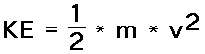
- Don’t forget your order of operations.
- PEMDAS
- For KE, you must do exponents (E) before multiplying (M). So square the velocity first, and multiply by half of the mass.

Kinetic energy
- Translational Energy: Motion from one location to another.
- Vibrational energy (sound)
- Electrical energy: Flow of electrons.
- Rotational energy.

Kinetic energy is a scalar quantity; as it does not have a direction.
- Velocity, acceleration, force, and momentum, are vectors. A quantity having direction as well as magnitude

- Mechanical Energy (ME) – Energy due to position and motion; sum of potential and kinetic energies. Includes heat and friction.
  - Just add Potential Energy + Kinetic Energy.

- Centripetal Force: A force that makes a body follow a curved path.

- Hydropower – Potential to Kinetic energy

- Speed: A measure of motion, = distance divided by time. D/T
- 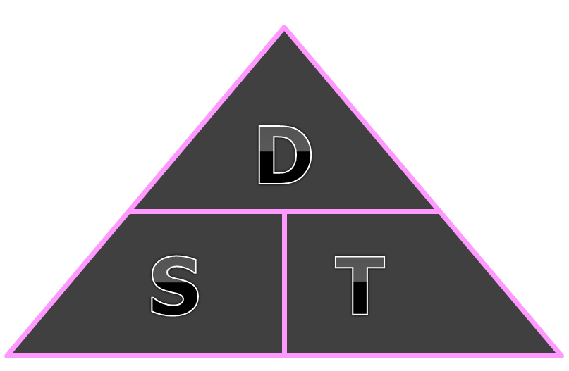

Distance = Speed * time (Multiply)
Speed = Distance divided by time
Time = Distance divided by Speed

- Velocity = Speed (distance / time) and direction.
- velocity = Distance Divided by Time

- Acceleration = The rate of change in velocity. (M/s²)
The final velocity – the starting velocity, divided by time.
also... a = (v₂ − v₁)/(t₂ − t₁₎

- Deceleration – To slow velocity.
The same formula but value will be negative.

- Momentum: A measure of the motion of a body equal to the product of its mass and velocity.
  - Momentum = Mass times velocity
  - Law Conservation of Momentum: The momentum of an object is the product of its mass and its velocity.
  - Angular momentum: Rotating objects tend to remain rotating at the same speed / direction unless acted upon.
  - When you draw the weights inward, your moment of inertia decreases, and your velocity increases (spin faster).

- Amount of Work (w) done depends on two things:
The amount of Force (F) exerted.

The Distance (d) over which the Force is applied.

- Equation for Work - w = F x d

- Joule: Unit of energy, work, or amount of heat.
  - Equal to the energy expended in applying a force of one newton through a distance of one meter.

- Catapults - By the law of conservation of energy, the stored potential energy (U) is transferred into rotational kinetic energy (K), with some loss due to friction. U = K

- Trajectory – The path of flying object: the path that a projectile makes through space under the action of given forces such as thrust, wind, and gravity.

- Force: Is a PUSH or a PULL, that causes a change in the motion or shape of an object
  - Gravity, Electricity, Magnetism, and Friction
- F = w x d.
- W = F x d

Machines…
  - Transfer force from one place to another.
  - Change direction of a force.
  - Increase the magnitude of a force.
  - Increase the distance or speed of a force.

- Machine: Anything that helps you do work.
  - Work = Force x Distance

Efficiency: A measure of how much more work must be put into a machine than you get out of the machine.
  - The efficiency of a machine will always be less than 100%.
  - If there was no friction, the best you could hope for is an efficiency of 100% meaning work in = work out.

- Law Conservation of energy: energy cannot be created or destroyed.
-Simple machines generally require more work / energy to complete a task.

- Force is a quantity which is measured using the standard metric unit known as the newton
- One newton is the amount of force required to give a 1-kg mass an acceleration of 1 m/s/s.
Quick Cheat Sheet
- Potential Energy (PE) = mass kg * gravity (9.8) * height (Answer is in Joules)

- Kinetic Energy (KE) = ½ mass kg * Velocity squared (velocity * Velocity) (Answer is in Joules)
  - Square velocity first because it an exponent (PEMDAS)

- Mechanical Energy (ME) = Kinetic Energy + Potential Energy (Answer is in Joules)

- Speed – A Measure of motion, = Distance divided by time (Answer in meters per second m/s)

- Velocity – Rate of which an object changes its position. = Distance divided by time and direction. (Answer in meters per second and direction such North, East, South, West, or Northwest etc.)

- Acceleration – Change in velocity over time. Final Velocity minus the starting velocity divided by time. (Answer is in meters / sec/ and direction North, etc.

- Deceleration – Same as acceleration but the number will be negative.

- Mass – Amount of matter in an object. On earth, weight and mass are the same. (Metric unit is the gram)

- Force = (F=MA) F = Mass (Weight on earth) * Acceleration (Answer is in newtons (m/s/s)

- Work – Force * Distance the force was applied (Answer is in newtons)

New Area of Focus: Simple machines

- Law Conservation of energy: energy cannot be created or destroyed.
Simple machines generally require more work / energy to complete a task.
But they….
  - Transfer force from one place to another.
  - Change direction of a force.
  - Increase the magnitude of a force.
  - Increase the distance or speed of a force.
    - This makes work seem easier.

To find Mechanical Advantage
  - Divide resistance force (usually weight in g) by the effort force (Newton)

  - Types of machines that do work with one movement.
Pulley
  - Uses grooved wheels and a rope to raise, lower or move a load.
Three types of pulleys
- A pulley makes work seem easier
  - Changes the direction of motion to work with gravity. Instead of lifting up, you can pull down.
  - Uses your body weight against the resistance.

- The more pulleys that are used, the more the MA (Mechanical Advantage).
- MA = The number of ropes that support the pulley. The end of the rope doesn’t count.

The three types of Pulleys
Fixed pulley
No Mechanical Advantage
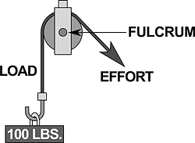

Movable Pulley
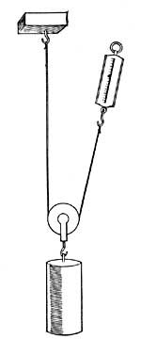

Combined Pulley / Block and tackle
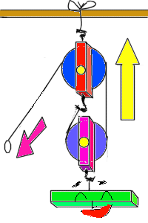
Lever
  - A stiff bar that rests on a support called a fulcrum which lifts or moves loads
  - MA = length of effort arm ÷ length of resistance arm.

The 3 types of levers
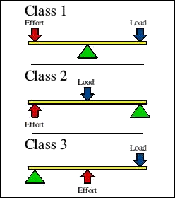

Third Class Lever.

  - Has Mechanical Disadvantage.
  - Requires more force to lift the load.

- Wedge: An object with at least one slanting side ending in a sharp edge, which cuts material apart.
  - The mechanical advantage of a wedge can be found by dividing the length of the slope (S) by the thickness (T) of the big end.

- Wheel and Axle: A wheel with a rod, called an axle, through its center lifts or moves a load.
  - The mechanical advantage of a wheel and axle is the ratio of the radius of the wheel divided by the radius of the axle.
  - Radius: A straight line from a circles center to its perimeter.

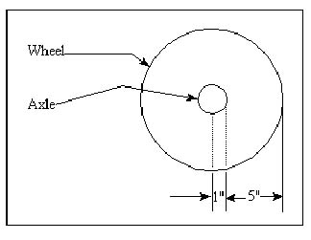
Divide 5 by 1

- An Inclined plane: A slanting surface connecting a lower level to a higher level
  - MA for an inclined plane is the length of the slope divided by the height (Rise).

- Screw: An inclined plane wrapped around a pole which holds things together or lifts materials.
  - The mechanical advantage of a screw can be found by dividing the circumference of the screw by the pitch of the screw.
  - The circumference of a circle is the distance around the circle. It is the circle's perimeter. The formula for circumference is:
    - Circumference = π times Diameter
    - C = πd
    - Where π = 3.14
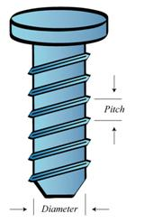 | 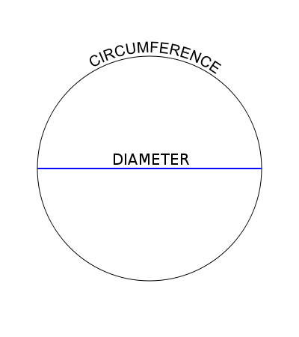

- Compound machines: Two or more simple machines working together.

DO NOT LOSE THESE NOTES! PLEASE PUT THEM IN YOUR SCIENCE FOLDER!

Copyright © 2010 Ryan P. Murphy

