Dear Valued Educator,

Thank you for your interest in this four year science curriculum. Each of the 20 units in the curriculum include a multi-part PowerPoint slideshow, bundled homework package, modified homework bundle, unit notes, answer keys, available worksheets that follow the slideshow, PowerPoint review games, crosswords, rubrics, general information folder and much more. The bundled homework and unit notes chronologically follow the unit slideshow. I print the bundled homework packages and hand them to the students on the first day of the unit. Homework becomes staying current with class topics. I also have the students use a white lined journal to record class activities, red slide notes, and much more. Available worksheets are provided and a slide within the slideshow alerts the teacher and students when these sheets are relevant. I allow students to use their journal to help them with their bundled homework package and PowerPoint review games. I also copy unit notes for the students who have difficulty / need extra assistance. Support staff can also benefit from a copy of the unit notes and answer version to the bundled homework package. A student version of the curriculum is also provided that is similar to the teachers but missing the answer keys, review games, and surprises meant for the classroom.
These science units are looking forward to your enthusiasm and creativity. Feel free to change the lessons to fit your own needs. Please read the pages below to get a better understanding of how to utilize these resources in your classroom. I have worked very hard through trial and error creating these resources and look forward to hearing your feedback. Once again, thank you for your interest and please feel free to contact me with any questions you may have.

Sincerely,

Ryan P. Murphy M. Ed
ryemurf@gmail.com
www.sciencepowerpoint@gmail.com

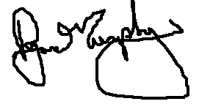

PowerPoint Slideshows

Teacher should have a version of PowerPoint on their computer or Keynote for Mac which is compatible. Classroom teachers should also have an LCD projector. I have modified my wall using white poster boards to create a wall size viewing area. The larger you can create a screen the better. Having a remote slide advancer with optional laser pointer is very helpful as most of the units have thousands of slides. I put many elastic bands around my remote presenter because you will eventually drop it and they tend to break easily. Teaching without the remote will limit your mobility and take lots of extra time and travel.

Each unit comes with a multi-part PowerPoint slideshow. The parts are labeled Part I, Part II, etc. and will chronologically guide you through an entire unit of study. A bundled homework package, unit notes, available worksheets, and more support the slideshow. A slide within the PowerPoint roadmap alerts the students and teacher of activity sheets, video links, homework checks, review games, and much more. I've tried to make everything in the unit chronological.

There are two types of slides, red slides and black slides. Both have value but red slides are considered critical class notes. A slide at the beginning of the unit describes how these slides should be recorded in the students’ journal neatly. These slides are very important for the bundled homework package and are usually important definitions or concepts. Class notes which are all of the red slides and more can be found in the folders and distributed to the students who struggle with note taking. Black slides have many purposes and students should pay attention and complete tasks as described.

Many links are provided to view videos, visit websites, take quizzes, and much more. Computers should have access to the internet. Many of the videos direct you to YouTube. If your school blocks YouTube you will need to visit those videos and download them from a home computer.

Red Slide Note Black Slide Activity
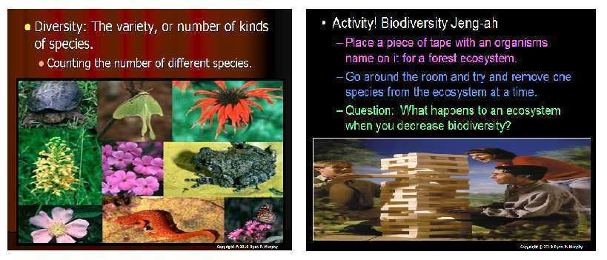
Lesson Planning

I have tried to space exciting hands-on activities, red slide notes, video and academic links, projects, simulations, readings, built-in quizzes, and review opportunities throughout the PowerPoint. A typical day may have many different learning styles being targeted. Daily lesson planning becomes advancing through the PowerPoint roadmap the night before and assessing how far you would like to get. I would recommend getting the materials ready in advance. There may be hand-outs / available sheets that should be printed up in advance. A slide with a visual is provided for the teacher and student. Each unit comes with a materials list, but going through the slideshow and examining the activities and their directions is recommended. A typical day may be addressing a question, seeing a video short, recording some red slide notes, conducting a small activity, and then answering some questions about the activity. Other days may be completing or planning a large project or large lab activity, taking one of the many review games, researching, or any combination of the above. There is enough content and variation in the learning that you can decide how far you want to advance in the slideshow. There are many questions in the slideshow, and you can open these questions up to table group conversation and then call upon students if you feel the students need it. It’s okay to skip ahead a bit and then cover some of the Areas of Focus another day. Keep in mind if skipping around that the PowerPoint Review Games, bundled homework, and lesson notes are chronological to the PowerPoint slideshow. If I get through an area of focus in a lesson and don't want to start something new, I may have the students work on the bundled homework package, check science journals, study the flashcards, and work on the coloring and labeling page, crossword puzzle, and much more. Using the available sheets that help the students organize and graph data can save time. You can also always address Common Core ELA with the “AYE” Advance Your Exploration worksheets.

Note: The units also work well without direct teaching from the teacher. I have run some units / sections of a unit by having the students follow the slideshow individually on personal computers in the classroom or at home. They then fill out the homework bundle as they move through the slideshow. The teacher can provide stations to conduct activities, headphones for videos, etc., and moves around the class checking progress and answering questions. The students usually do very well moving through the slideshow on their own once they have the system down. This use of the material also makes for a terrific subplan if needed. I was once out for two weeks with knee surgery and my students completed most of an entire unit on their own.

Student Version of the Curriculum
The student version is a great resource to distribute to students so that they can access class lessons at home. I will post each part of the PowerPoint roadmap to the students school email account. I will also post on the PowerPoint roadmaps to the school web page. I even have the students bring in a 4 GB flash drive and manually load the entire student curriculum at the beginning of the year. The student version of the curriculum allows students and parents to answer questions to the homework, visit academic links that explore topics in greater detail, and allow students who may have been absent to catch up quickly. This is a huge help for some students to complete the homework bundle. The student curriculum is very similar to the teachers but is missing the answer keys, review games, modified homework bundle, box games, owl, and surprises meant for the classroom. It is also missing the materials list and folders meant for the teacher. The questions to the built-in quizzes are provided but the answers and bonus questions are removed.

Available Sheets

The slideshows are set-up for journaling in a notebook / bound journal where students record red slide notes, answer questions, create spreadsheets, and so on. The available sheets for each Part of the PowerPoint slideshow allow the teacher to print these resources in advance and distribute them to the students for class work. It's a nice option for teachers who don't favor journaling. I use a combination of the available sheets and journaling on an as needed basis. Students tend to favor the journal in my opinion. A slide in the slideshow points out the location / question to be addressed on the available class work sheet. The worksheets are meant to follow the slideshow chronologically. A slide is provided with a visual that tells the teacher and reminds the students what part of the worksheet is being addressed next.

The available sheets hold the students a bit more accountable as they can be collected and graded at the end of the class. I don't generally collect the science journals everyday as the students need them to complete their homework. The available sheets can be used as part of a classwork grade if you choose. Once handed back, they're also a great resource to use on the bundled homework package and review games.

The lab oriented available sheets have the spreadsheets, procedures, blank graphs, and questions built-in. These lab sheets are great as time is always a crunch and the creating of spreadsheets / blank graphs and questions in a journal is time consuming and difficult for some students. These worksheets are usually due immediately after the activity. These sheets can also be helpful for those students who continually struggle or are unable to complete a journal.

Available Sheet Classwork Slide to remind teacher - Sheet (.doc) found in folder.
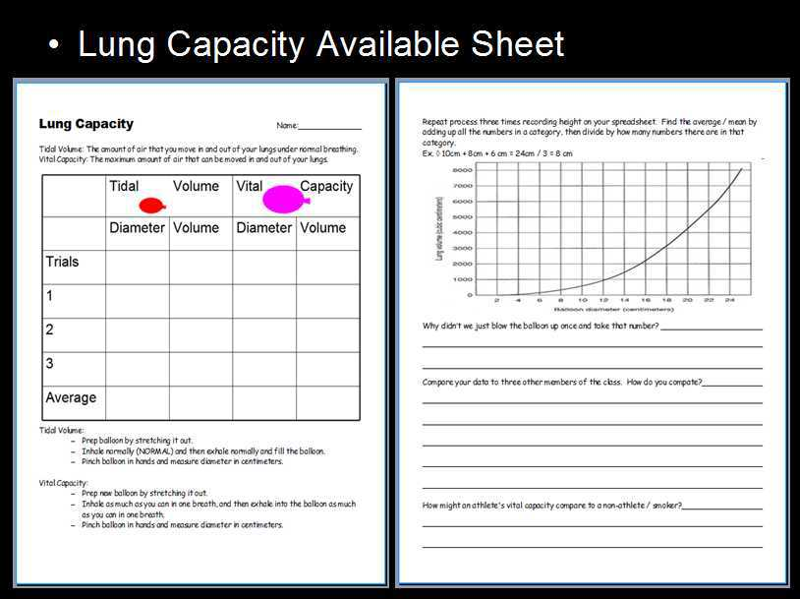

Bundled Homework Package

Each unit comes with a bundled homework package. I print the bundle before the unit begins and distribute to the students on the first day of the unit. The bundled homework package will be due shortly after the completion of the unit. I allow students to use their journals created in class (from red slide notes and activities), the internet, parents, and peers.

The package chronologically follows the multi-part PowerPoint slideshow. Slides built-into the slideshow remind the students and teacher where they should be on the homework. Nightly homework then becomes staying current with class instruction. Students should on average be putting 15-20 minutes into their bundled homework every night but tailor this time to your own schools policies. I spend a considerable amount of time at the beginning of the year / unit describing what quality looks like on the homework. Organizing the homework as a bundle allows the students to complete the homework on their schedule, working more one night, and less on another.

Be aware of some students who let things go to the last minute. The other disadvantage is when a student loses a bundle they lose all of their work at once. I have provided a homework rubric for grading. I try and check the bundled homework packages often. This alerts me to the students who are not staying current, and provides a restart place if a student loses the homework near the due date.

A modified version of the bundled homework package is also provided that look a lot like the original. This version is significantly shorter, many of the multi-part questions are removed, and the font is larger as are the lines for writing. These modified versions are a nice starting place to begin making individual accommodations for the students who require. The modified versions of the bundled homework are not provided in the student version of each unit just to eliminate the student conversations that would emerge from having it available alongside the more difficult version.

I also spend considerable time describing the rules for completion of the homework. I let students work together as long as there is no direct copying / just giving of the answers. I encourage students to share where they found the answer in their journal.

Answers Keys to both bundled homework packages are provided in the answer key folder. These are great to send to parents and support professionals to help them assist students. As far as grading goes, I generally use the rubric and tend to reward effort and hard work. I spend a lot of time showing examples of "A" work and put a large emphasis on neatness and content. You will find that these units are built for students to be successful if they are willing to work hard. Coloring is not necessary but it doesn't hurt if done well. Remind the students to use the environmental print to assist them on spelling. The teacher could assign a value for each question on the homework if you wish and grade accordingly.

This is a slide that reminds teacher and student what page they should complete on the bundled homework package. I require the students to record this info into their assignment book when this slide appears. It keeps the students organized.
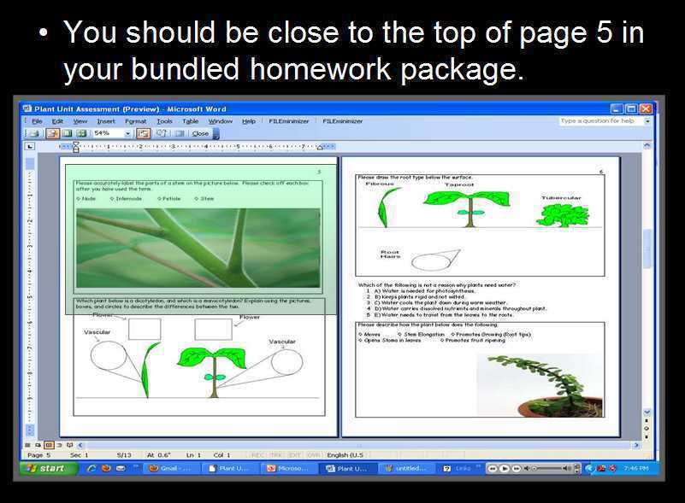
Unit Notes

Unit notes are all of the red slide notes and much more. They also follow the slideshow chronologically. They are intended to help a student who may need them. I generally print them up at the beginning of the unit and distribute them to those students. I have also given them to every student in the class (usually the first unit of the year). In these cases they're encouraged to be a useful tool to aid students in the journaling process. Red slide notes can be difficult for some students and having the notes nearby keeps the class moving forward in a timely fashion. I have had some students use highlighters to follow along with class instruction. Students who need the notes should be instructed to pull them out every day for class. I then slowly remove the supplied notes from the students who do not need them. I also give support staff a copy of the notes and parents who may want them. These notes are very helpful for the bundled homework package that also chronologically follows the slideshow. Having a few extra copies of the notes laying around is helpful for students who were absent or going to be absent. A copy of the notes is provided in the student folder which is very helpful but most students will use the student version of the slideshow for assistance if given a choice.

Unit Notes (Example)
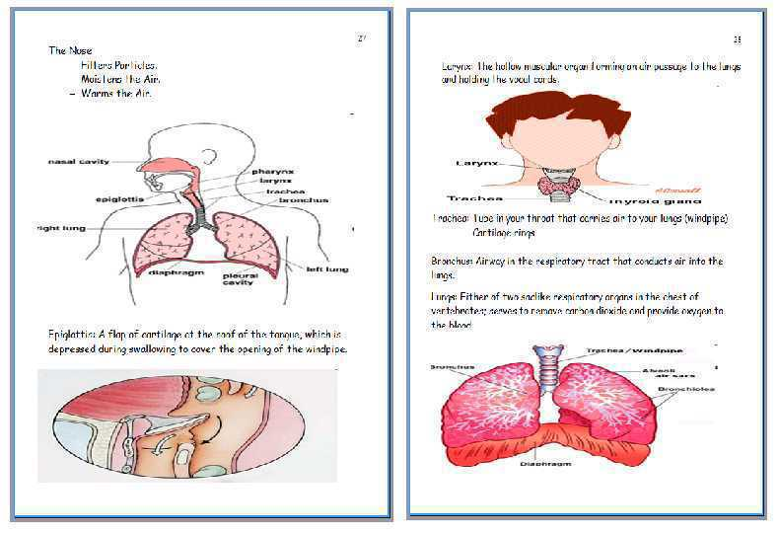
PowerPoint Review Games

PowerPoint Review games look a lot like that familiar game show Jeo_ _ _ _ _ . I don't play them the same way. A slide usually located at the end of a slideshow / Part will alert the teacher and student that it's time for a PowerPoint Review Game. A template sheet is provided in the activities folder for the PowerPoint Review Games 1-25. Students should record the name of the game and the categories into the boxes. The answers are provided in PowerPoint form at the end and I have the student’s grade themselves. The question is presented before the answer is revealed so the teacher can call upon students or table groups. A non-answer key version is also provided to give students who may have missed the game.

You will find the PowerPoint Review Games in a folder appropriately named. Students should record the topic of the Review Game on the topic line of their sheet. They should also record the name of each category to keep the game organized.

I allow students to work in small table groups and will allow them to use their science journals. With group collaboration and the use of journals the scores are usually very high. I have the students practice what quiet group communication sounds like. On occasion I will remove group work privileges if table groups get too loud in their answering. To make the games more difficult you can remove the use of journals. In these situations I alert the students that they will need to study the night before. I have allowed the use of one note card as a reference / cheat sheet.

To run the game, advance through the slide show from the beginning starting with question #1 and ending with the final question. Each question 1-20 is worth 5pts. Questions 20-25 are all for fun bonus questions worth one point. The bonus questions usually have something to do with the game title and the students really enjoy this round. The final question is usually a 5pt wager. Students make their wager at the bottom before the question is presented. If they wager 5pts they can gain or lose 5. The owl is hiding somewhere in the review game and students should secretly write the word owl at that question when they see it. Students should be reminded not to shout out "owl" or to let anyone outside of their group know. The Owl is worth 1 point.

Review games are great resources to review and use class content one last time. They're great to use on a Friday after a long week, or on a Monday to review material from the prior week. If running out of time, I will collect the sheets and run the answers the next day for even more review. The students enjoy these games and the bonus rounds are meant to make the review challenge more fun. You could add more academic questions into this column if you wish. They are also a terrific sub-plan if needed as they take about 40 minutes to complete.

Picture of PowerPoint Review Game and Blank Template.
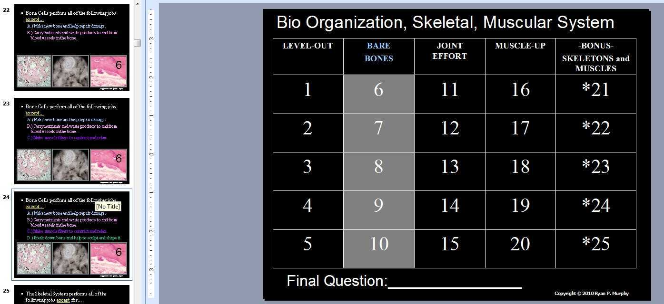

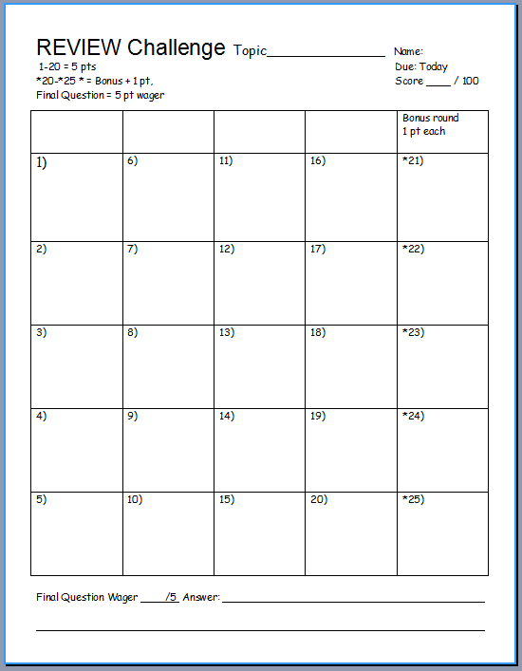

Video Links

Each unit has many video links about relevant topics. Most videos are short clips that range in length from 2 - 6 minutes. The length of the video is usually shown in the thumbnail image beneath video link. Most of the videos link you to YouTube. If YouTube is blocked at your school or your computer is not connected to the internet the videos and other links won't work. In this case, you will need to download the video the night before and save them as a file and bring them into class. You can use YouTube Downloader http://youtubedownload.altervista.org/ or other programs to download these videos in any number of compatible formats for your computer. Downloading and organizing the videos also insures that they will be available next year if the video is removed from the internet. A few slides will link your class to longer movies. Information in the slide lets you know that the videos are longer in length. Many videos are labeled optional. I like to have options during the lesson. If I don't think I can make it to the larger activity coming up in the slideshow then I might show some of the optional videos. If I'm pressed for time, then I might skip the videos and revisit them later or not at all. Some of the videos are really catchy songs about a science concept, or your more traditional science video. Having a few crazy videos about science keeps things exciting. Since your linking to YouTube, some videos may require your class to view a few seconds of ads which your students will love but drives me crazy. If you download the videos in advance then you can just pull up the video from a folder without the ads. I try and mute the ads. If a link is broken please let me know. I try and check the links periodically but cannot spend every day seeing if all of the links are still active.

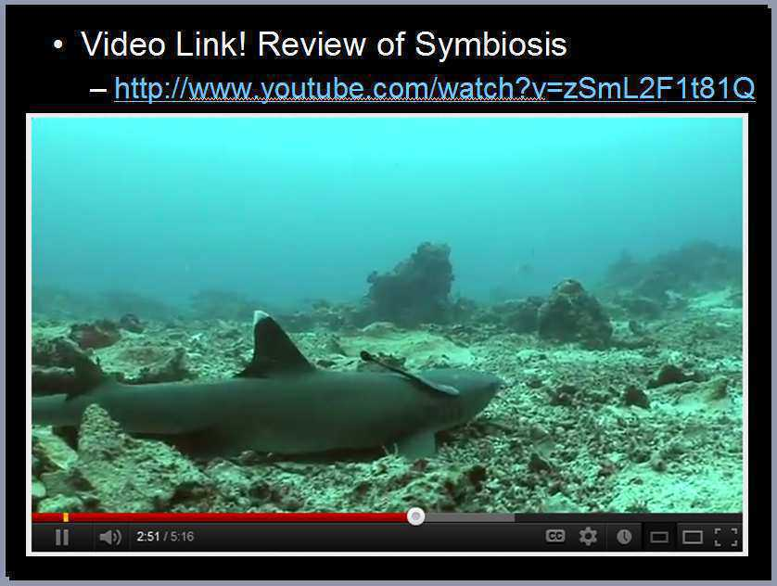

Common Core / The Next Generation in Science Standards – Topics in each unit, Next Generation Science Standards, and other standards are presented at the beginning of the unit. The standards are also covered in more detail in the curriculum folder with specific details. The standards and topics in each part of the multi-part PowerPoint are highlighted. Each unit also includes an “AYE” Advance Your Exploration worksheet that allows your students to visit the many provided academic links. This worksheet corresponds to the Common Core Standards for ELA and Literacy for Science and Technical Subjects. Students can use this worksheet to visit the many provided academic links or provided your own readings.

Visit http://www.nextgenscience.org/search-standards to learn more about the Next Generation Science Standards and http://www.corestandards.org/ELA-Literacy/RST/introduction for Common Core ELA and Literacy in Science and Technical Subjects.

The Owl - This was something I tried a few years ago and the students went bonkers and demanded more. Each Part of the slideshow has a small clipart Owl hiding somewhere in a slide. The owl is incredibly small and I try to blend it into just the right slide. If a student spots the owl they can raise their hand high into the air. When you call upon them they can say "owl". I usually have some small reward on hand such as a +5 on a review game, +2 on a bundled homework card, or inexpensive candy item. Each PowerPoint Review game also has an owl hiding in it worth one point. Remind the students that they secretly write the word "owl" rather than yell it out during the review games. The kids love the owl which is great but sometimes I just want to move on without it. Feel free to delete the owl if you wish. It does keep some students that may normally create distractions focused on the board like squirrels watching for owls.
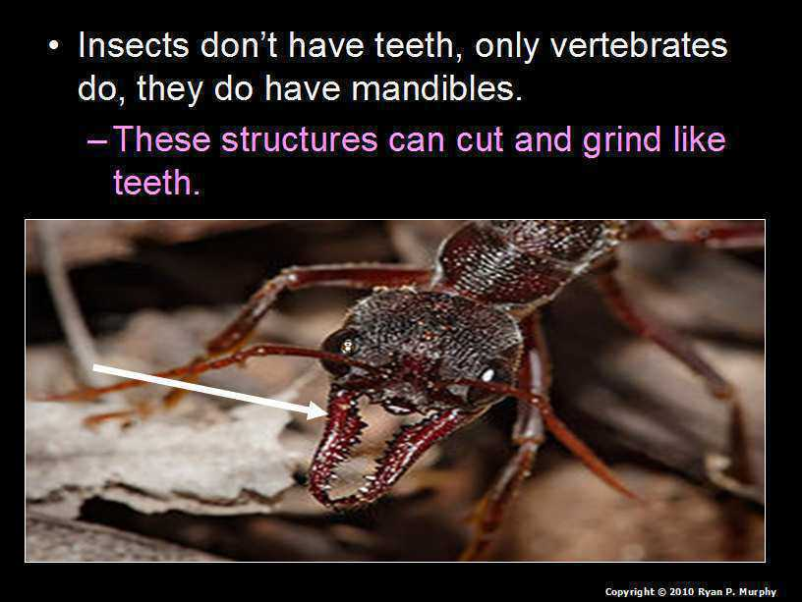
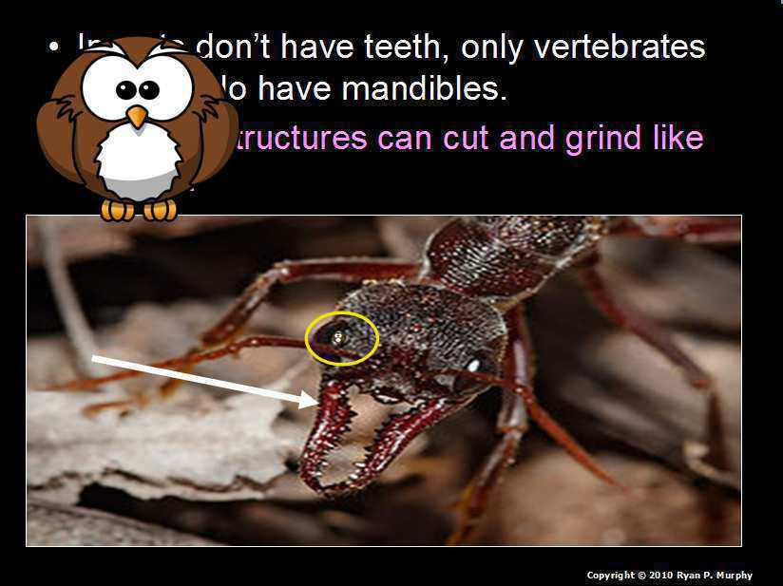


Quiz Wiz – You can decide to grade these with the provided Quiz Wiz scoring sheet or to have the students record them in their science journal. Some of the available sheets also have the Quiz Wiz built-in. I usually have the students record the quiz in their science journal and just use as it a tool for assessing understanding. A few Quiz Wiz activities get the students out of their seats and make symbols to show their answer. I don't usually grade these but they are great for the teacher to look out and see which students are confused. The last question is a for fun bonus question. The answers are provided at the end of the quiz. The question is placed before the answer so you can call on students or table groups to share answers etc. before advancing.
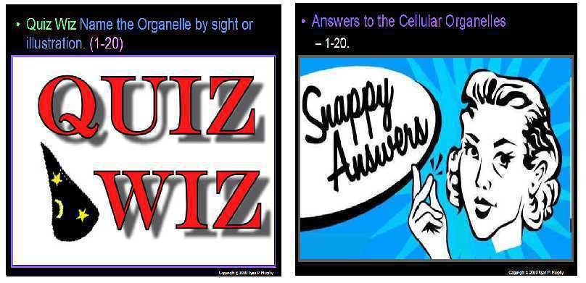
Hidden Box Games - At the end of each Part of the PowerPoint roadmap you will find three or more hidden box games. A relevant slide from that part of the PowerPoint is hidden beneath some shapes. Each advance of the slide removes more the shapes blocking the picture. Students only get one guess and should raise their hand when they think they know. I will often run the activity as a group game where the tables only get one guess. This gets the groups quietly communicating. I try and have a reward handy for those who guess correctly. The picture is revealed at the end and usually a final message provided. These are a great way to review materials during those final minutes of class.

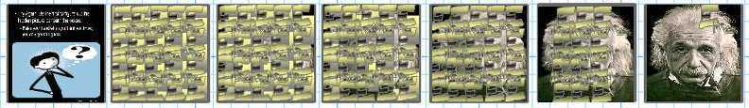

Shape Moving Activities - Some activities in the slideshow has the teacher minimize out of the slideshow and assist students to move shapes. I send students up to the board to pretend to move the shapes (.jpegs) around. I control their movements on the computer controlling the slideshow. They reach up and pretend to drag a piece of a puzzle or other image to complete a task. They make the movement deliberate, and the teacher moves the actual shape. Teacher must reset the images for the next class. I usually have few slides with the scattered pieces if you run multiple classes in a day.
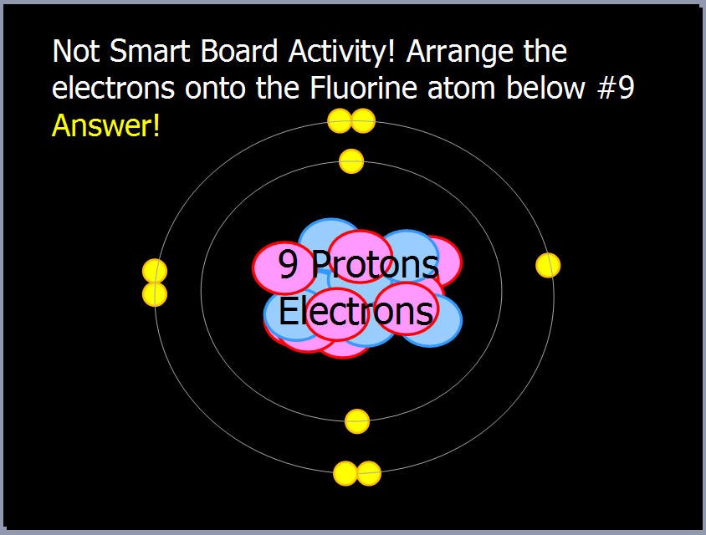
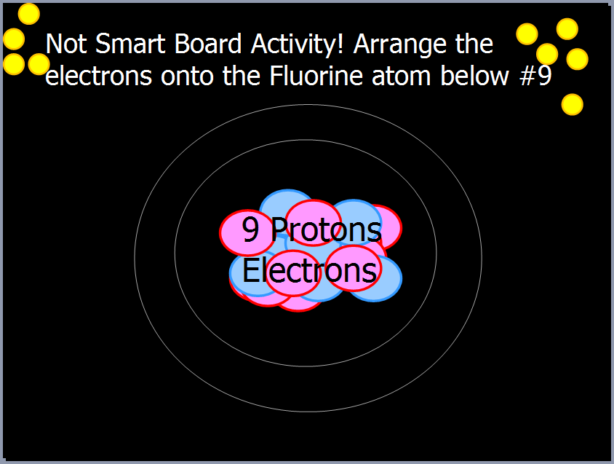
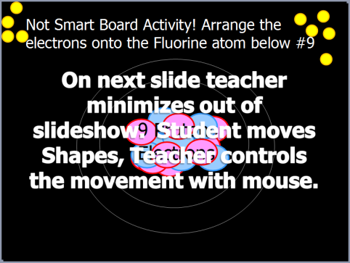

Moving Quiz- Some units have moving quizzes at the end of the slideshow. The teacher needs to label the four corners of the room with A, B, C, D on the wall. Each slide presents a multiple choice question. Students have a few seconds to read the slide and then slowly walk to the correct corner. I encourage the students to wander a bit before making their decision. I usually do a countdown before students need to be in a corner. After a few warm-up questions if you get one wrong you have to sit down. If the last person left in the game gets the question wrong then everyone else is back in. It's a strange idea but it somehow has evolved that way in my class and the kids like it. These are a nice way to work some movement into the lesson and review materials at the same time. Remind students to walk slowly and please watch out for tripping hazards. If I catch a student running they are automatically out.

Learn more links: On several slides within a unit I have provided a link to learn more. I don't generally visit these sites during the lesson. These are provided in the student version and are intended for students who want to learn more. These are great resources for your students who are really excited about the material. The link will take your student to a slightly more advanced version of what we just learned. Browsing through the internet for great sites is time consuming and these links help get your students to these sites and then back to the PowerPoint roadmap. If a link has become broken please contact me so I can fix it. I check every link when I cover that lesson with my students but can’t spend every day checking the hundreds of provided links.

Poll the Class Slides: Many slides will have relevant terms covered with a box. When advancing through the slideshow an outline around the box will glow with a bright color. The next slide will make the box disappear. These slides allow the teacher to call upon students or table groups / check for understanding before advancing. I’ve found that using this technique helps to keep the students focused. Constantly recalling and reviewing information learned is necessary when moving through a large unit. I don’t like to just give everything away for free in a PowerPoint. Students should be able to demonstrate knowledge before moving on. Some slides have full questions instead of just covered terms. In these slides, I like to encourage small group work. I will then call upon one or two groups to share before advancing the slide / presenting the answer or new area of focus.
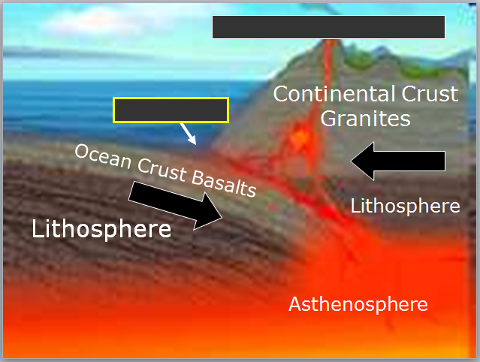

Coloring and Labeling Pages - Each unit comes with a coloring and labeling page. I have put one at the end of the bundled homework and also provided one in the activities folder. Slides at the end of each Part of the PowerPoint roadmap provide some answers / remind the students of what to do. These reminders are also in the student version of the slideshow. This is a very abstract assignment but the students generally do well. They should record information in the white spaces around the pictures / questions. The example below is not what the finished product should look like but just reminds students what should be neatly written in pen next to the pictures. They should then color the pictures only and not the white space with the writing. I collect all of the coloring and labeling pages throughout the year and then hand them out for the last few days of the year to work on. Students share answers / lessons learned throughout the year. They then tape the coloring and labeling pages together to create a door sized poster that I laminate. Students usually put the posters on their wall at home and keep them for many years. They are a nice quick reference for science questions and keep sake of their journey in science class.
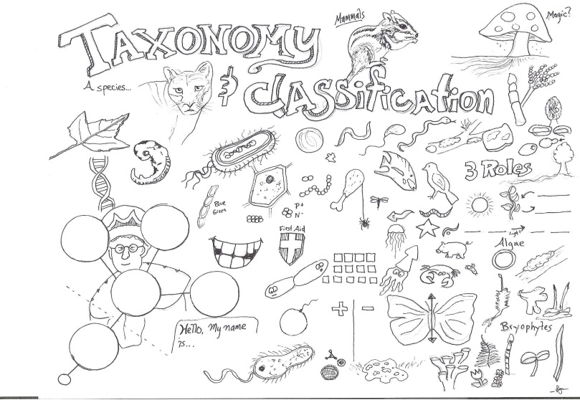 | 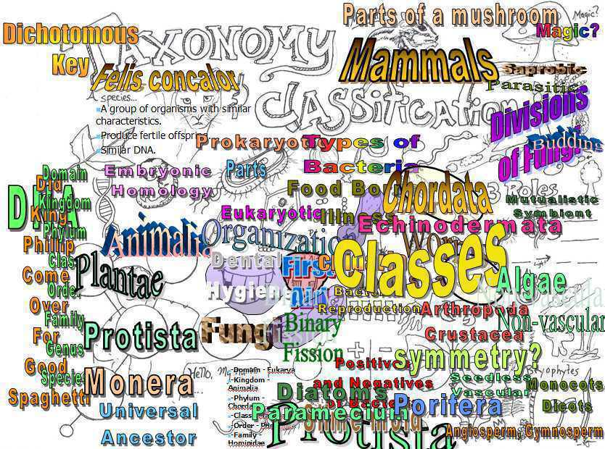
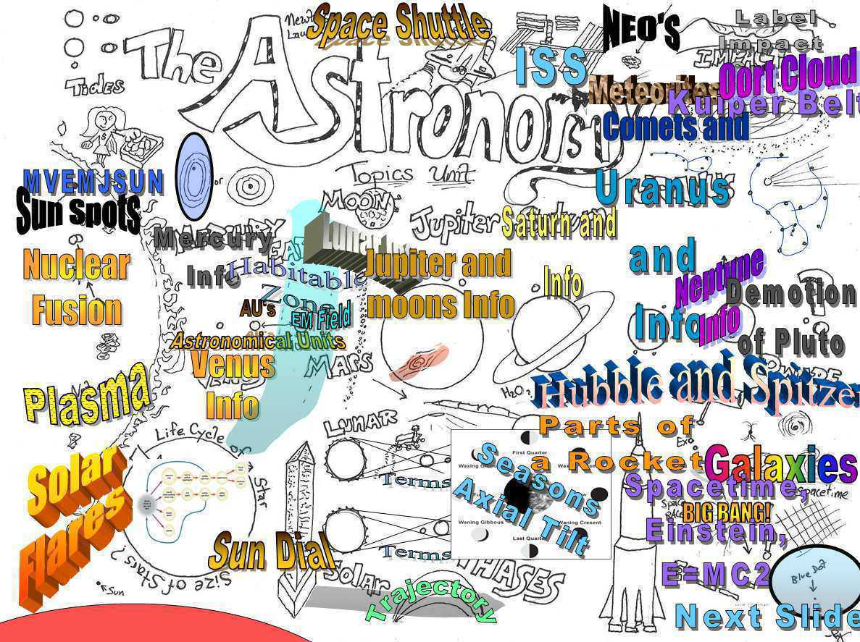 | 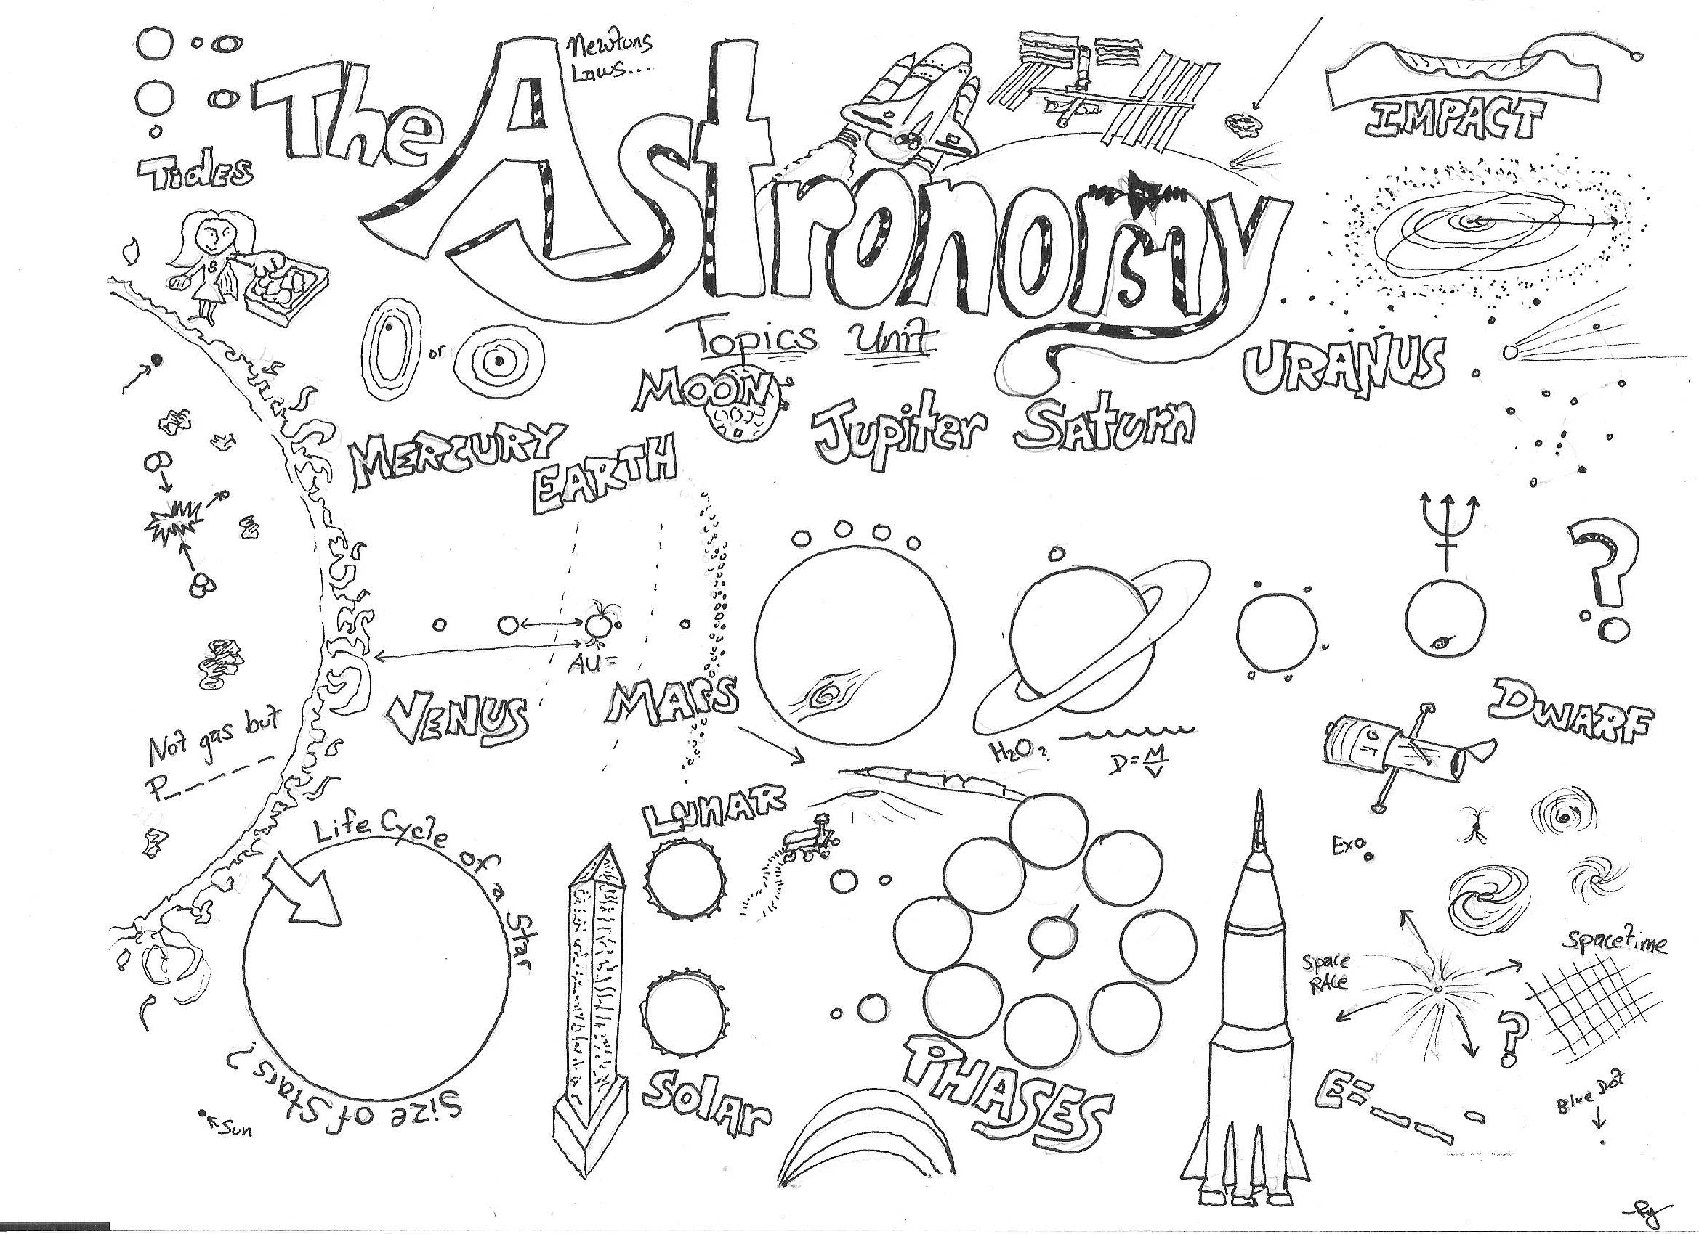

Crossword Puzzles - Each Unit also comes with a crossword puzzle and solution. They are provided at the end of the bundled homework and in the available sheet folders. A word bank can be added or removed to make the crossword more or less difficult. They're generally quite challenging and using the student journals is helpful. They have saved me for those situations that require an immediate sub-plan.
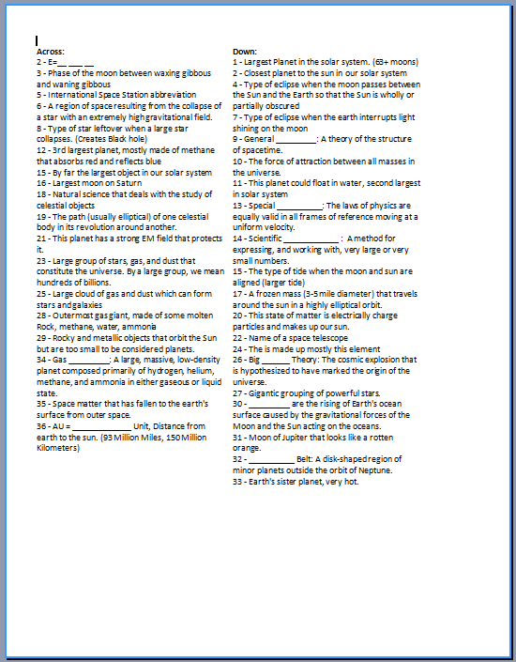
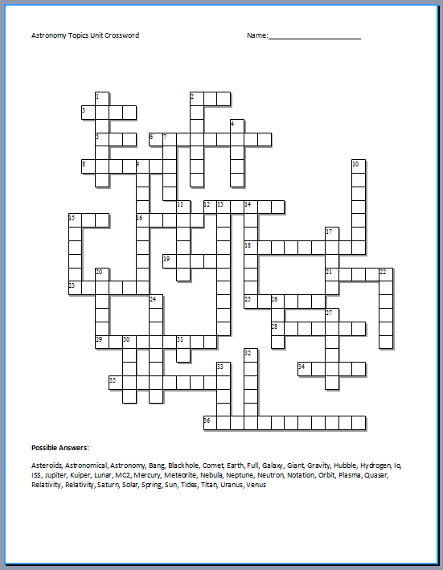
Flash Cards - Most units also come with a flash card set. Directions are provided at the top of the Flash Card Set. Some flash cards have the students move the cards around to create a match between term, definition, and picture on a large flat surface. Other sets are more traditional flash cards. I usually have a class make the flash cards and then put them in plastic bags. Once they are made they are a great resource to have on hand and after the unit can be used the next year. The Flash Cards are also provided in the student version.

Rubrics - Grading Rubrics are provided for the bundled homework package and student science journals. Specific rubrics are provided for most projects in each of the units. A slide in the slideshow reminds teachers that a grading rubric is present. Another slide may show the rubric on the slideshow so the teacher can go over it with the students. The journal rubric and bundled homework are more quick check rubrics but do have several comment lines at the bottom for the teacher.
Curriculum Guide

Difficulty Rating 1/10 (10 is Most Difficult)

5th or 6th or 7th Grade Year
Ecology: Feeding Levels Unit 4/10 (Life Science Ecology)
Ecology: Interactions Unit 5/10 (Life Science Ecology)
Water Molecule Unit 5/10 (Earth Science Water Topics)
Ecology: Abiotic Factors Unit 6/10 (Life Science Ecology)
Botany Unit 6/10 (Life Sciences)
Evolution / Change Topics Unit 7/10 (Life Science Ecology)
Rivers, Lakes, and Water Quality Unit 6/10 (Earth Science Water Topics)
Soil Science and Ice Ages Unit 6/10 (Earth Sciences)

6th or 7th or 8th Grade Year
Introduction to Science Unit 7/10 (Physical Science Concepts)
Astronomy Unit 7/10 (Earth Sciences)
Geology Topics Unit 7/10 (Earth Sciences)
Weather and Climate Unit 7/10 (Earth Sciences)
Classification and Taxonomy Unit 8/10 (Life Sciences)
Human Body and Health Topics Unit 8/9/10 (Life Science / Health)

8th / 9th / 10th Year
Motion and Machines Unit 8/10 (Physical Sciences)
Matter, Energy, and the Environment Unit 8/10 (Physical Sciences)
Atoms and Periodic Table Unit 9/10 (Physical Sciences)
Infectious Diseases Unit 8/10 (Life Sciences)
Cellular Biology Unit 9/10 (Life Sciences)
DNA and Genetics Unit 9/10 (Life Sciences)

Note - These are just ratings based on my experiences over the last several years. Please visit the sample PowerPoints and files for the bundled homework / unit assessments to better gauge the difficulty rating and appropriate unit for your students. If you have any questions please contact me at ryemurf@gmail.com or www.sciencepowerpoint@gmail.com

Thanks again for your interest in this curriculum,

Sincerely,

Ryan Murphy M.Ed.

These are some combinations that I have used that work well.

5th grade year
Ecology: Feeding Levels Unit 4/10 (Life Science Ecology)
Ecology: Interactions Unit 5/10 (Life Science Ecology)
Ecology: Abiotic Factors Unit 6/10 (Life Science Ecology)
Botany Unit 6/10 (Life Sciences)

6th grade year
Water Molecule Unit 5/10 (Earth Science Water Topics)
Rivers, Lakes, and Water Quality Unit 6/10 (Earth Science Water Topics)
Soil Science and Ice Ages Unit 6/10 (Earth Sciences)
Geology Topics Unit 7/10 (Earth Sciences)
Weather and Climate Unit 7/10 (Earth Sciences)

7th grade year
Science Skills Unit 6/10 (Physical Science)
Astronomy Unit 7/10 (Earth Sciences)
Evolution / Change Topics Unit 7/10 (Life Science Ecology)
Human Body and Health Topics Unit 8/10 (Life Science / Health)

8th / 9th / 10th Year
Motion and Machines Unit 8/10 (Physical Sciences)
Matter, Energy, and the Environment Unit 8/10 (Physical Sciences)
Atoms and Periodic Table Unit 9/10 (Physical Sciences)
Infectious Diseases Unit 7/10 (Life Sciences)
Cellular Biology Unit 9/10 (Life Sciences)
Classification and Taxonomy Unit 8/10 (Life Sciences)
DNA and Genetics Unit 9/10 (Life Sciences)
These are some other combinations that I have used that work well.

5th grade year
Ecology: Feeding Levels Unit 4/10 (Life Science Ecology)
Ecology: Interactions Unit 5/10 (Life Science Ecology)
Ecology: Abiotic Factors Unit 6/10 (Life Science Ecology)
Water Molecule Unit 5/10 (Earth Science Water Topics)
Rivers, Lakes, and Water Quality Unit 6/10 (Earth Science Water Topics)

6th grade year
Soil Science and Ice Ages Unit 6/10 (Earth Sciences)
Geology Topics Unit 7/10 (Earth Sciences)
Astronomy Unit 7/10 (Earth Sciences)
Weather and Climate Unit 7/10 (Earth Sciences)

7th grade year
Botany Unit 6/10 (Life Sciences)
Evolution / Change Topics Unit 7/10 (Life Sciences)
Infectious Diseases Unit 7/10 (Life Sciences)
Classification and Taxonomy Unit 8/10 (Life Sciences)
Human Body and Health Topics Unit 8/10 (Life Science / Health)

8th / 9th / 10th Year
Science Skills Unit 6/10 (Physical Science)
Motion and Machines Unit 8/10 (Physical Sciences)
Matter, Energy, and the Environment Unit 8/10 (Physical Sciences)
Atoms and Periodic Table Unit 9/10 (Physical Sciences)
Cellular Biology Unit 9/10 (Life Sciences)
DNA and Genetics Unit 9/10 (Life Sciences)

If interested in some general standards / areas of focus in each unit please examine the provided descriptions of each unit below. Once again, thank you for your interest and best wishes.

Ecology and the Environment: Trophic Feeding Levels Unit
-Creation and monitoring of students bio-domes.
-Areas of Focus: Areas of Focus within The Feeding Levels Unit: What is Ecology, Concepts in Ecology, Concept-There is no such thing as a free lunch, Energy Comes from the Sun, Food Chains, Trophic Feeding Levels, Producers, Consumers, Decomposers, Aquatic Food Chains, Phytoplankton, Zooplankton, Animal Dentition, Carnivores, Herbivores, Pyramid of Biomass, Pyramid of Numbers.

Next Generation Science Standards (NGSS)
MS.LS2.3 (Develop a model to describe cycling of matter and flow of energy among living and nonliving parts of an ecosystem).
- This standard is addressed throughout this unit with a focus on how energy moves from the sun, to the producers, and then to the consumers and decomposers. The flow of matter within the nonliving parts of an ecosystem is addressed heavily in the abiotic factors unit.

5.PS3.1 (Use models to describe that energy in animals food that is used for body repair, growth, and motion was once energy from the sun).
- This is standard is covered throughout with class notes, step by step drawings, video links, images, diagrams, flow charts, and much more.

5.LS2.1. (Develop a model to describe the movement of matter among plant, animals, and decomposers, and the environment)
- Several activities, video links, step by step diagrams / flow charts, and more address this standard.

HS.LS2.4. (Use mathematical representations to support claims for the cycling of matter and flow of energy among organisms in an ecosystem)
- Students learn about biomass pyramids, pyramid of numbers, and the concepts of matter and energy being conserved as it flows though the ecosystem. The mathematics in this unit is not H.S. level but the concepts and numbered representations of energy flow are made easy to understand for all.

3-5.ETS1.1 (Make observation and measurements to identify materials based on their properties).

Traditional standards addressed in the Ecology Trophic Feeding Levels Unit
Below are just a few of the typical standards that this unit addresses for those that are interested. This unit does cover many standards that are not addressed below.

●Work effectively within a cooperative group setting, accepting and executing assigned roles and responsibilities.

●Keep a journal record of observations, recognizing patterns, summarizing findings, and reflecting on the observations.

●Describe how energy is transferred through food webs in an ecosystem, and explains the roles and relationships between producers, consumers and decomposers.

●Recognize that one of the most general distinctions among organisms is between plants, which use sunlight to make their own food, and animals, which consume energy-rich foods.

●Recognize that energy, in the form of heat, is usually a byproduct when one form of energy is converted to another, such as when living organisms transform stored energy to motion.

●Explain how insects and various other organisms depend on dead plant and animal matter for food, and describe how this process contributes to the system.

●Describe the Sun as the principle energy source for phenomena on the Earth’s surface and necessary for life.

●Recognize that one of the most general distinctions among organisms is between plants, which use sunlight to make their own food, and animals, which consume energy-rich foods.

●Given an ecosystem, trace how matter cycles among and between organisms and the physical environment (includes water, oxygen, food web, decomposition and recycling.

●Organize observations and data into tables, charts and graphs.

Ecology and the Environment: Interactions Unit

-Areas of Focus within The Ecology Interactions Unit: Levels of Biological Organization (Ecology), Parts of the Biosphere, Habitat, Ecological Niche, Types of Competition, Competitive Exclusion Theory, Animal Interactions, Food Webs, Predator Prey Relationships, Camouflage, Population Sampling, Abundance, Relative Abundance, Diversity, Mimicry, Batesian Mimicry, Mullerian Mimicry, Symbiosis, Parasitism, Mutualism, Commensalism, Plant and Animal Interactions, Coevolution, Animal Strategies to Eat Plants, Plant Defense Mechanisms, Exotic Species, Impacts of Invasive Exotic Species.

Next Generation Science Standards (NGSS)
MS.LS1.4 (Provide evidence / use argument to explain animal behaviors and plants structures to increase successful reproduction)
- This is covered in plant animal interactions, seed dispersal mechanisms, symbiosis.

MS.LS1.5 (Discuss and explanation for how envs. factors influence the growth of an organism)
- This is covered throughout the unit as the big abiotic factors are described

MS.LS2.1 (Interpret data to provide evidence for the effects of resource availability on organisms and populations in an ecosystem).
- Student record notes, see video links, and partake in a really neat simulation that has them collect seeds. Several reminder slides reviews with the students that as resources increase populations generally increase. Habitat, predator prey games, and much more cover this standard well.

MS.LS2.4 (Describe with evidence that changes to the physical or biological components of an ecosystem can affect populations).
- Students learn about food webs and the interconnectedness of species. Teacher uses string to connect students representing various organisms in a food web together. The web collapses as changes in the food web unfold. Discussion follows with a set of slides that discuss the needs of living things and how changes in these needs can affect the population. Other limiting factors are addressed and some video links provided. Several data collecting activities associated with populations of organisms are provided.

MS.LS2.2 (Explain a pattern of interactions among organisms across multiple ecosystems).
- Types of competition are described as well as competitive exclusion theory. Predator prey relationships provided and some neat hands-on class simulations provided. Types of symbiosis including mutualisms, plant animal interactions, and much more are described. Niche, needs of living things, and the effects of exotic species in an ecosystem are also provided. This unit is called the Ecology Interactions unit and addresses this standard throughout.

MS.LS2.5 (Evaluate competing design solutions for maintaining biodiversity and ecosystem services).
- The importance of wetlands is addressed for their cleaning and purifying values as well being an important habitat to maintain biodiversity. Biodiversity as well as the importance of biodiversity is addressed. Ways to maintain biodiversity by decreasing human interference, decreasing habitat destruction, and maintaining keystone species is described. A series of challenge questions are provided.

5.ESS2.1 (Develop an example to describe ways the geosphere, biosphere, hydrosphere, and atmosphere interact).
- Slides provide several examples and also describe what each sphere is. Other units such as the abiotic factors unit and weather unit make deeper connections and these spheres are addressed again.

3-5.ETS1.1 (Make observation and measurements to identify materials based on their properties).

3-5.ETS1.2 (Define a simple design problem reflecting a need or want that included specified criteria for success with materials, time, or cost)

HS.LS2.5 (Develop a model to illustrate the role of photosynthesis and cellular respiration in the cycling of carbon among the biosphere, atmosphere, hydrosphere, and geosphere).
- Students learn the process of photosynthesis and respiration in the form of notes, games, video links, activities, and review opportunities. Reference to carbon being cycled throughout the biosphere is addressed in a series of slides made easy for the student to understand.

HS.LS2.1 (Use mathematical and/or computational representations to support explanations of factors that affect carrying capacity of ecosystems at different scales).
- Human population growth and other animation population graphs (predator / prey) are addressed. Human population growth includes several models, graphs, historical information, exponential growth activity, and with video and academic links. Carrying capacity, limiting factors (density dependent and density independent), and R vs. K selected species are addressed in a series of slides with visuals. This is done in a way for younger and older students to understand.

HS.LS2.2 (Use mathematical representations to support and revise explanations based on evidence about factors affecting populations in ecosystems).
- The mathematics is middle school, but student’s collect, average, graph, and explains trends in population changes in several activities.

HS.LS2.8 (Evaluate evidence for the role of group behavior on individual and species change to survive to reproduce).
- Students learn about animal behaviors such as flocking, school, herding and the advantages that they bring. Students record notes, see visuals, video links, and partake in a resource gathering exercise. Questions follow the activity.

HS.LS2.6 (Evaluate the claims, evidence, and reasoning that the complex interactions in ecosystems maintain relatively consistent numbers and types of organisms in stable conditions, but changing conditions may result in a new ecosystem).
- Students learn about limiting factors (density dependent and independent), carrying capacity (r and K selection), and predator prey relationships. Several slides describe disturbances that can change the ecosystem. Students learn that K selected species don’t usually exceed their carrying capacity.

HS.LS2.2 (Use mathematical representations to support and revise explanations based evidence about factors that affect biodiversity and populations).
- Students learn about the factors that affect and the importance of maintaining biodiversity. Students also learn to calculate relative abundance and species abundance and graph their findings.

HS.LS2.7 (Design, evaluate, and refine a solution for reducing the impacts of human activities on the environment and biodiversity).
- Students learn the importance of maintaining biodiversity and then are provided some ways to reduce the impact on species. A series of slides with visuals encourage the prevention of habit loss, increasing laws and regulations, conserving land, parks, protecting keystone species, and minimizing human interference. A neat video link compares plantation forestry to native regeneration forestry in Tasmania.
- Traditional standards addressed in the Ecology Interactions Unit
Below are just a few of the typical standards that this unit addresses for those that are interested. This unit does cover many topics/ standards that are not addressed below.

●Keep a journal record of observations, recognizing patterns, summarizing findings, and reflecting on the observations.

●Identify the resources plants and animals need for growth and energy, and describe how their habitat provides these basic needs.

●Recognize that the transfer of energy through food is necessary for all living organisms and describes the organization of food webs.

●Recognize that plants and animals interact with one another in various ways besides providing food, such as seed dispersal or pollination.

●Recognize and describe the hierarchical organization of living systems, including cells, tissues, organs, organ systems, whole organisms, and ecosystems.

●Explain that most microorganisms do not cause disease and that many are beneficial to the environment.

●Describe ways plants and animals depend on each other.

●Recognize that some living things, which lived on Earth long ago, are now extinct, such as dinosaurs, mammoths, giant tree ferns, and horsetail trees.

●Define a population as all individuals of a species that exist together at a given place and time, and explain that all populations living together in a community, along with the physical factors with which they interact, compose an ecosystem.

●Identify and describe the ways in which organisms interact and depend on one another in an ecosystem, using food webs.

●Identify the potential impact of converting forested land to uses such as farms, homes, factories, or tourist attractions.

●Define a population as all individuals of a species that exist together at a given place and time; and explain that all populations living together in a community, along with the physical factors with which they interact, compose an ecosystem.

●Provide examples of how all organisms, including humans, impact their environment; and explain how some changes can be detrimental to other organisms.

●Use a variety of tools and formats (oral presentations, journals, and multimedia presentations) to summarize and communicate the results of observations.

●Organize observations and data into tables, charts and graphs.

Ecology and the Environment: Abiotic Factors Unit
-Includes Isopod formal lab report.
- Areas of Focus within The Ecology: Abiotic Factors Unit: Abiotic Factors, Biotic Factors, The Big 7 Abiotic Factors, Organisms Range of Tolerance, Light, How light affects Organisms, Photosynthesis, Factors in the Environment that Affect the Amount of Light, How Organisms Movements are affected by light, Bioluminescence, How temperature affects organisms, Thermoregulation, Physiological Regulation, Behavioral Regulation, Adaptation, Hypothermia, Hyperthermia, Warm-Bloodedness (endothermy), Cold-Bloodedness, Hibernation / Torpor, Advantages of Warm-Bloodedness, Disadvantages of Warm-Bloodedness, Advantages of Cold-Bloodedness, Disadvantages of Cold-Bloodedness, Water, Water Requirements and Plants, Adaptations of Plants and Water, Adaptations of Animals and Water, Wind, Positives and Negatives of Wind to Organisms, How animals use Wind, How Plants use Wind, Wind Dispersal, Water Dispersal, Animal Seed Dispersal, Fire Ecology, Fire Dependence, Biogeochemical Cycles, Hydrologic Cycle, Carbon Cycle, Photosynthesis, Cellular Respiration, Oxygen-Carbon Dioxide Balance, Nitrogen Cycle, Phosphorus Cycle, Importance of Phosphorus, Nutrients and Aquatic Systems, Eutrophication.

Next Generation Science Standards (NGSS)
MS.LS1.4 (Provide evidence / use argument to explain animal behaviors and plants structures to increase successful reproduction)
- This is covered in seed dispersal mechanisms, how animal use wind and water, fire ecology, and also Island Biogeography.

MS.LS1.5 (Discuss explanation for how ends. factors influence the growth of an organism)
- This is covered throughout the unit as the big abiotic factors are described (Light, Temp, Water, Air), also as part of Photosynthesis, Respiration, Biogeochemical Cycles, and more.

MS.PS1.3 (Gather and interpret info that synthetic materials come from natural resources and impact society)
- Students learn about acid rain and air pollution as well as climate change and nutrient pollution.

MS.LS1.5 (Create an explanation from evidence for how environmental and genetic factors influence growth of organism).
- Environmental factors that such as light, temperature, and moisture are addressed throughout. Photosynthesis and cellular respiration are described in detail. Fertilizers and nutrients are addressed in the nitrogen and phosphorus cycles with class notes, video links, step by step drawings, questions, homework, and more.

MS.LS1.6 (Create an explanation from evidence for the role of photosynthesis in the cycling of matter and flow of energy into and out of organisms).
- This standard is addressed heavily as students visit many interactive slides about photosynthesis. Students learn about how the energy flow of life comes from the sun and that plants create sugars. What goes into and out of plants is addressed. Students learn the biochemical processes of photosynthesis (beyond and boundary). Video and academic links, review opportunities and more are provided.

MS.LS1.7 (Create model to describe how food is rearranged through chemical reactions forming new molecules that support growth and / or release energy).
- Cellular respiration is described in this unit. Student’s record notes, answer questions, see video and academic links. The biochemical process is described and reviewed in a step by step process (beyond the boundary). The remainder of this standard is covered in the digestive system portion of the human body unit.

MS.LS2.3 (Develop a model to describe cycling of matter and flow of energy among living and nonliving parts of an ecosystem).
- This standard is addressed throughout the entire unit with a focus on the nonliving parts of an ecosystem. Biogeochemical are addressed in detail with an emphasis on how matter moves from the living to the non-living. Notes, review games, step by step drawings, questions, homework and more address this standard. Energy flow is addressed heavily in the feeding levels unit.

HS.LS1.3 (Plan and conduct an investigation to provide evidence that feedback mechanisms maintain homeostasis).
- Students learn about behavioral and physiological adaptations to the cold and heat. The Isopod lab report also deals with maintaining balance in the environment.

HS.LS1.3 (Use a model to illustrate how photosynthesis transforms light energy into stored chemical energy).
- Students create a detailed sketch of what goes into and out plants. The lesson also addresses the photosynthetic equation. Exciting video links, text, visuals, and constant review help to reinforce. This unit does not address the Calvin Cycle in detail except by providing a detailed video link of the biochemical processes.

HS.LS1.7 (Use a model to illustrate that cellular respiration is a chemical process whereby the bonds of food molecules and oxygen molecules are broken and the bonds in new compounds are formed and result in a transfer of energy).
- The inputs of and outputs of cellular respiration are addressed. This unit does not go in the biochemical processes of the citric acid cycle in detail but does provide visuals, and video / academic links.

5.PS1.1. (Develop a model that matter is made of particles too small be seen). Particles are addressed when biogeochemical cycles are covered.

5.ESS2.1 (Develop an example to describe ways the geosphere, biosphere, hydrosphere, and atmosphere interact).
- Slides provide several examples and also describe what each sphere is how they are connected. Student then learn the biogeochemical cycles in detail and how they interact with the living and nonliving world.

3-5.ETS1.1. (Make observation and measurements to identify materials based on their properties).

3-5.ETS1.2 (Define a simple design problem reflecting a need or want that included specified criteria for success with materials, time, or cost)

3-5.ETS1.3 (Generate and compare multiple possible solution to a problem based on how well each is to meet criteria and constraints of the problem)

Traditional standards addressed in the Ecology Abiotic Factors Unit
Below are just a few of the typical standards that this unit addresses for those that are interested. This unit does cover many topics / standards that are not addressed below.

●Keep a journal record of observations, recognizing patterns, summarizing findings, and reflecting on the observations.

●Identify and describe the factors that affect the number and types of organisms an ecosystem can support, including the resources that are available, the range of temperatures, the composition of the soil, disease, the threat of predators, and competition from other organisms.

●Explain that most microorganisms do not cause disease and that many are beneficial to the environment.

●Describe the process of photosynthesis and explain that plants can use the food they make immediately or store it for later use.

●Provide examples of how all organisms, including humans, impact their environment and explain how some changes can be detrimental to other organisms.

●Explain how changes in environmental conditions can affect the survival of individual organisms and the entire species.
Given a scenario, trace the flow of energy through an ecosystem, beginning with the sun, through organisms in the food web, and into the environment (includes photosynthesis and respiration)

●Demonstrate the appropriate use of tools, such as thermometers, probes, microscopes and computers to gather, analyze and interpret data in the life sciences.

●Explain how water exists in the atmosphere in different forms and describes how it changes from one form to another through various processes such as freezing, condensation, precipitation and evaporation.

●Recognize that water can be a liquid or a solid; and explain that it can be made to change from one state to the other, but the amount (mass) of water always remains the same in either state.

●Explain the processes that cause cycling of water into and out of the atmosphere and their connections to our planet’s weather patterns.

●Recognize that elements exist in fixed amounts and describe how they move through the solid Earth, oceans, atmosphere, and living things as part of geochemical cycles, such as the water, carbon and nitrogen cycles.

●Describe the interaction of living organisms with nonliving things.

●Provide examples of how environmental changes can cause different effects on different organisms.
Using information (data or scenario), explain how changes in the environment can cause organisms to respond (e.g., survive there and reproduce, move away, die).

●Recognize that for any particular environment, some kinds of animals and plants survive well, some less well, and some cannot survive at all.

●Recognize that humans need food, water, air, waste removal and a particular range of temperatures in their environment, just as other animals do.

●Explain why it is beneficial for an organism to be able to regulate its internal environment while living in a constantly changing external environment.

●Explain how the processes of photosynthesis and cellular respiration are interrelated and contribute to biogeochemical cycles.

●Plan a step-by-step process to solve a practical problem or to carry out a “fair test” of a simple scientific question.

●Use a variety of tools and formats (oral presentations, journals, and multimedia presentations) to summarize and communicate the results of observations.

●Organize observations and data into tables, charts and graphs.

Plant Topics / Botany Unit
-Areas of Focus in The Plant Unit: Cool Facts about Plants, Plant Evolution, Importance of Algae, Lichens, The Three Types of Lichens, Non-Vascular Plants, Bryophytes, Seedless Vascular Plants (Ferns), Seeds, Seed Dormancy, Factors that Break Seed Dormancy, Germination, Parts of a Young Plant, Monocots and Dicots, Roots and Water, Types of Roots, Water Uptake and Photosynthesis, Plant Hormones, Types of Plant Tissues, Xylem and Phloem, Woody Plants, Leaves, Light and Plants, Transpiration, Guard Cells, Leaf Identification, Plant Life Cycles, Seed Plant Life Cycles, Parts of a Flower, Matured Ovaries (Fruits), Types of Fruit.

Next Generation Science Standards (NGSS)
MS.LS1.4 (Provide evidence / use argument to explain animal behaviors and plants structures to increase successful reproduction)
- This is covered in seed dispersal mechanisms, Plant Life Cycles, Parts of a Flower, Fruits, and also within seedless vascular plants.

MS.LS1.5 (Create an explanation from evidence for how environmental and genetic factors influence growth of organism).
- Environmental factors that such as light, temperature, and moisture are addressed throughout. Photosynthesis and cellular respiration are described in detail. Fertilizers and nutrients are addressed in the nitrogen and phosphorus cycles. Students also design and carry out their own investigations with plant growth. Many of these projects will investigate how changes in environmental factors affect plant growth / fitness.

MS.LS1.6 (Create an explanation from evidence for the role of photosynthesis in the cycling of matter and flow of energy into and out of organisms).
- This standard is addressed heavily as students visit many interactive slides about photosynthesis. Students learn about how the energy flow of life comes from the sun and that plants create sugars. What goes into and out of plants is addressed. Students learn the biochemical processes of photosynthesis (beyond and boundary). Video and academic links, review opportunities and more are provided.

5.PS1.1. (Develop a model that matter is made of particles too small be seen). Particles are addressed when photosynthesis is covered.

5.PS1.1. (Support an argument that plants get the materials they need for growth chiefly from the air and water).
- Students learn about hydroponics, see a video, and conduct an activity with hydroponics in the classroom. Review slides and video links reinforce this standard

3-5.ETS1.1. (Make observation and measurements to identify materials based on their properties).

3-5.ETS1.2 (Define a simple design problem reflecting a need or want that included specified criteria for success with materials, time, or cost)

3-5.ETS1.3 (Generate and compare multiple possible solution to a problem based on how well each is to meet criteria and constraints of the problem)

HS.LS1.3 (Use a model to illustrate how photosynthesis transforms light energy into stored chemical energy).
- Students create a detailed sketch of what goes into and out plants. The lesson also addresses the photosynthetic equation. Exciting video links, text, visuals, and constant review help to reinforce. This unit does not address the Calvin Cycle in detail except by providing a detailed video link of the biochemical processes.

Traditional standards addressed in the Botany / Plant Topics Unit
Below are just a few of the typical standards that this unit addresses for those that are interested. This unit does cover many topics / standards that are not addressed below.

●Keep a journal record of observations, recognizing patterns, summarizing findings, and reflecting on the observations.
Work effectively within a cooperative group setting, accepting and executing assigned roles and responsibilities.

●Explain that most microorganisms do not cause disease and that many are beneficial to the environment.

●Describe the reproductive process of plants, explaining some plants grow from seed, while others grow from the parts of other plants.

●Recognize that living organisms have life cycles, which include birth, growth and development, reproduction, and death; and explain how these life cycles vary for different organisms.

●Describe the process of photosynthesis and explain that plants can use the food they make immediately or store it for later use.

●Recognize that plants and animals interact with one another in various ways besides providing food, such as seed dispersal or pollination.

●Plan a step-by-step process to solve a practical problem or to carry out a “fair test” of a simple scientific question.
Use a variety of tools and formats (oral presentations, journals, and multimedia presentations) to summarize and communicate the results of observations.

●Apply a variety of age-appropriate strategies to address real-life issues (e.g., identify factors that affect plants in a particular habitat).

●Organize observations and data into tables, charts and graphs.

●Build a concept map (or other graphic organizer) to understand a complex problem.

Water Molecule Unit
-Areas of Focus within the Water Molecule Unit:-Locations of Water on the Planet, Importance of Water, Groundwater, Groundwater Pollution, The Water Molecule, Properties of Water, Polarity, Cohesion, Adhesion, Capillary Action, High Specific Heat, and Water has a Neutral pH, Lower Density of Ice. Water is the Universal Solvent, Mixtures.

Next Generation Science Standards (NGSS)
MS.ESS2.4 (Create a model to describe the cycling of water through Earth’s systems driven by energy from the sun and the force of gravity).
- Students create a step by step drawing of the water cycle. The role of the sun and gravity within the cycle are mentioned throughout. Many review slides and built-in activities are spread throughout. Changes in the states of matter and throughout the water cycle are described.

MS.ESS3.3 (Apply science principles to design a method for monitoring the minimizing a human impact on the environment).
- Students learn about water depletion when too much water is withdrawn from an underground aquifer.

5-PS1-1. (Develop a model that matter is made of particles too small be seen).
- The molecular structure of water is covered. Behavior or these particles / properties of water are also addressed.

HS.ESS3.1 (Construct an explanation based on evidence for how the availability of natural resources, occurrence of natural hazards, and changes in climate have influenced human activity).
- Emphasis in this unit is placed on the availability of water on planet Earth and ground water pollution. The positives and negatives are addressed surrounding hydraulic fracturing.

3-5.ETS1.1 (Make observation and measurements to identify materials based on their properties).

3-5.ETS1.2 (Define a simple design problem reflecting a need or want that included specified criteria for success with materials, time, or cost)

3-5.ETS1.3 (Generate and compare multiple possible solution to a problem based on how well each is to meet criteria and constraints of the problem)

Traditional standards addressed in the Water Molecule Unit
Below are just a few of the typical standards that this unit addresses for those that are interested. This unit does cover many topics / standards that are not addressed below.

●Keep a journal record of observations, recognizing patterns, summarizing findings, and reflecting on the observations.

●Explain the properties that make water an essential component of the Earth’s system, including solvency and its ability to maintain a liquid state at most temperatures.

●Explain that water quality has a direct effect on Earth’s life forms.

●Identify the physical and chemical properties that make water an essential component of the Earth’s system.

●Explain the processes that cause cycling of water into and out of the atmosphere and their connections to our planet’s weather patterns.

●Organize observations and data into tables, charts and graphs.

●Recognize and describe the Earth’s surface as mostly covered by water.

●Explain that most of Earth’s water is salt water, which is found in the oceans, and that fresh water is found in rivers, lakes, underground sources, and glaciers.

Rivers, Lakes, and Water Quality Unit
-Areas of Focus within The Rivers and Water Quality Unit: Watersheds, Rivers of the United States, Sections of a River, Parts of River (Vocabulary), Stream Order, Erosion and Deposition, Water Quality, Chemical Properties of Water, Bio-Indicators of Water Quality (EPT richness), Physical Properties of Water Quality, Rivers and Flooding, Factors that Control Flooding, Types of Flooding, Tsunami’s, Wetlands, Flood Prevention, Levees, Dams and Ecosystem, Importance of Dams, Impacts of Dams, Hydropower, Parts of Dam, Salmon (Life Cycle), Systems of Help Salmon, Fish (General), Layering in a Lake, Lake Turnover, Nutrients and Lakes.
-Water Quality Assessment Lab Report

Next Generation Science Standards (NGSS)
MS.ESS3.3 (Apply science principles to design a method for monitoring the minimizing a human impact on the environment).
- Student design a levee system to mitigate the effects of flooding on a community. Students also learn about hydroelectric dams and their positive and negative effects. Students also study the importance of wetlands in flood prevention with a nice series of slides and activities.

HS.LS4.6 (Create a simulation to test a solution to mitigate adverse impacts of human activity on biodiversity).
- Students discuss issues in a role playing activity that brings a hydroelectric dam into their community. Students research and politely argue both sides of the issue and biodiversity is an important player in the town discussion.

HS.ESS3.1 (Construct an explanation based on evidence for how the availability of natural resources, occurrence of natural hazards, and changes in climate have influenced human activity).
- This unit addresses flooding, tsunami’s, hydroelectric dams, and levee systems.
HS.ESS3.2 (Construct an explanation based on evidence for how the availability of natural resources, occurrence of natural hazards, and changes in climate have influenced human activity).
- Students also learn about hydroelectric dams and their positive and negative effects/ Student’s research the issues associated with hydroelectric dams and then role in a town meeting format. Evidence is shared and final vote occurs.

Traditional standards addressed in the Rivers, Lakes and Water Quality Unit
Below are just a few of the typical standards that this unit addresses for those that are interested. This unit does cover many topics / standards that are not addressed below and much more.

●Keep a journal record of observations, recognizing patterns, summarizing findings, and reflecting on the observations.

●Describe how water flows into and through a watershed, falling on the land, collecting in rivers and lakes, soil, and porous layers of rock, until much of it flows back into the ocean.

●Describe and define the different landforms on the Earth’s surface, such as coastlines, rivers, mountains, deltas, canyons, etc.;

●Use results from an experiment to draw conclusions about how water interacts with earth materials (e.g., percolation, erosion, and frost heaves).

●Demonstrate the appropriate use of tools, such as thermometers, probes, microscopes and computers to gather, analyze and interpret data in the life sciences.

●Provide examples of technology that have changed the environment and explain whether the effect had a positive or negative impact.

●Provide examples of how all organisms, including humans, impact their environment; and explain how some changes can be detrimental to other organisms.

●Use a variety of tools and formats (oral presentations, journals, and multimedia presentations) to summarize and communicate the results of observations.

●Organize observations and data into tables, charts and graphs.

Astronomy Unit
-Areas of Focus in the Astronomy unit: Astronomy, The Solar System and the Sun, Order of the Planets, Our Sun, Solar Eclipse, Lunar Eclipse, The Inner Planets, Mercury, Venus, Earth, Moon, Craters, Tides, Phases of the Moon, Mars and Moons, Rocketry, Asteroid Belt, NEO’s, The Outer Planets and Gas Giants, Jupiter / Moons, Saturn / Moons, Uranus / Moons, Neptune / Moons, The Kuiper Belt, Oort Cloud, Comets / Other, Beyond the Solar System, Black holes, Exoplanets, The Big Bang, The Special Theory of Relativity, Hubble Space Telescope, Constellations and much more.

Next Generation Science Standards (NGSS)
MS.LS1.5 (Construct and present arguments using evidence to support claims that gravity attracts objects and this attractiveness depends on the mass of interacting objects.)
- This is described throughout the unit. The solar system, orbits of planets (speed / year) and their distance from the sun described. Gravity is also described in Life Cycles of Stars, black holes, neutron stars and within the rocketry portion of the unit. When each planet is described, students guess how much a 100 lb. person on earth would weigh on each planet. Part V pays specific attention to Einstein and space-time. This is one of those standards that show up continuously throughout the unit.

MS.ESS1.1 (Develop a model of the Earth, Sun, and Moon systems to describe the cyclic patterns of lunar phases, eclipses of the sun, moon, and seasons).
- This standard is covered heavily in Part I, and Part II of this unit. Students read slides, see visuals, watch video links, and much more. Students create step by step drawings of solar and lunar eclipses, as well as create sun dials. Students use OREOS among other methods to learn the lunar phases. Seasons and axial tilt are also heavily addressed.

MS.ESS1.2 (Develop a model to describe the role of gravity in the motion within galaxies and the solar system).
- Elliptical orbits are described with visuals, animations, and having students recreate orbits by moving around a sun in the classroom. The speed of planetary orbits and their distance from the sun is addressed. This concept is addressed throughout the unit.

MS.ESS1.3 (Analyze and interpret data to determine scale properties of objects in the solar system).
- This standard is covered throughout. Students learn about Astronomical Units and conduct a walking distance tour of the solar system. Students learn about layers of the sun, the relative sizes of suns, light years, distances to stars, planetary information and much more. Examples of statistical information, drawings, animations, and much more are provided throughout.

5.PS1.1. (Develop a model that matter is made of particles too small be seen).
- Atoms are addressed with discussion of fusion in the sun. Other references to atoms and molecules are covered throughout.

5.PS2.1. (Support an argument that the gravitational force exerted by Earth on objects is directed downward).
- This standard is addressed throughout unit and goes into detail in Part III about rocketry.

5.PS2.1. (Support an argument that the differences in the apparent brightness of the sun compared to other stars is due their relative distances from the Earth.) This is addressed in part I with comparison of our sun in the sky and relative distances to our next closest star Proxima Centauri 39,900,000,000,000 km away.

5.ESS1.2. (Represent data in graphical displays to reveal patterns of daily change in length and direction of shadows, day and night, and the seasonal appearance of some stars in the night sky).
- This is addressed in part V just before constellations. Slides with notes, questions, and neat video link that use an umbrella, doll (observer), and sticky dots (stars) to demonstrate this standard.

HS.ESS1.1 (Develop a model based on evidence to illustrate the life span of the sun and the role of nuclear fusion in the sun’s core to release energy in the form of radiation).
- Covered with visuals, text on slides, video links, and constant review. Several animation slides are also provided. Life cycles of stars is also addressed as are solar flares.

HS.ESS1.2 (Construct an explanation of the Big Bang theory based on astronomical evidence of light spectra, motion of galaxies, and the composition of matter in the universe).
- This is addressed in a series of slide with visuals and explanations. A video link also provided.

HS.ESS1.3 (Communicate scientific ideas about the way stars, over their life cycle produce elements.)
- Nucleosynthesis is briefly addressed in the slideshow. Emphasis was placed on nuclear fusion. Life cycles of stars and the stages that occur is covered with step by step visuals.

HS.ESS1.4 (Use computation representations to predict the motion of orbiting objects in the solar system).
- Newton’s Law of Gravity is described. Kepler’s three laws of planetary motion are addressed. Emphasis placed on the Laws of ellipses and equal areas. Activity, visuals, animations, and links are provided.

3-5.ETS1.3 (Plan and carry out fair test in which variables are controlled and failure points are considered to identify aspects a prototype that can be improved)
- The rocketry unit has students build rockets from soda bottles.

Traditional standards addressed in the Astronomy Topics Unit
Below are just a few of the typical standards that this unit addresses for those that are interested. This unit does cover many topics / standards that are not addressed below and much more.

●Keep a journal record of observations, recognizing patterns, summarizing findings, and reflecting on the observations.

●Recognize and describe how the regular and predictable motions of the Earth and Moon explain certain Earth phenomena, such as day and night, the seasons, the year, shadows and the tides.

●Recognize that of all the known planets, Earth appears to be somewhat unique, and describe the conditions that exist on Earth that allow it to support life.

●Recognize how the tilt of the Earth's axis and the Earth's revolution around the Sun affect seasons and weather patterns;

●Identify and describe seasonal, daylight and weather patterns as they relate to energy.

●Explain the historical perspective of planetary exploration and man’s achievements in space, beginning with Russia’s Sputnik mission in 1957;

●Describe man’s perception of the constellations throughout history, and explain how he has used them to his advantage, including navigational purposes and to explain historical events.

●Recognize that of all the known planets, Earth appears to be somewhat unique; and describe the conditions that exist on Earth that allow it to support life.

●Explain the temporal or positional relationships between or among the Earth, Sun and Moon (e.g., night/day, seasons, year, tide).

●Recognize the relationships between the tides and the phases of the moon; and use tide charts and NOAA information to describe them.

●Recognize and describe how the regular and predictable motions of the Earth and Moon account for phenomena, such as the phases of the Moon and eclipses.

●Identify the characteristics of the Sun and its position in the universe.

●Recognize how the tilt of the Earth’s axis and the Earth’s revolution around the Sun affect seasons and weather patterns.

●Explain how the Solar System formed from a giant cloud of gas and debris about 5 billion years ago.

●Define a light year.

●Explain that current scientific evidence supports the Big Bang Theory as a probable explanation of the origin of the universe, and describes the theory.

●The Earth is part of a solar system, made up of distinct parts, which have temporal and spatial interrelationships.

●The origin and evolution of galaxies and the universe demonstrate fundamental principles of physical science across vast distances and time.

●The growth of scientific knowledge in Earth Space Science has been advanced through the development of technology

●Recognize the basic patterns of the Sun, including its appearance during the daytime, and how its position in the sky changes through the seasons.

●Recognize the basic patterns of the Moon, including its appearance sometimes at night and sometimes during the day; and how it appears to change shape through the month.

●Recognize that the Sun, Moon and stars all appear to move slowly across the sky.

●Recognize that as the position of the Sun changes in relation to the Earth it creates shadows of varying length and direction.

●Explain that night and day are caused by the Earth’s rotation on its axis; and that the Earth rotates approximately once, every 24 hours.

●Recognize that the light and heat the Sun provides to the Earth is necessary for life.

●Recognize that the Sun provides the light and heat necessary to maintain the temperature of the Earth.

●Recognize that astronomical objects in space are massive in size and are separated from one another by vast distances.

●Recognize there are too many stars to count, and that they are unequal in their brightness.

●Recognize and describe the stars, like the Sun, as spherical in nature.

●Identify the characteristics and movement patterns of the planets in our Solar System and differentiate between them.

●Explain the effects of gravitational force on the planets and their moons.

●Explain why Earth and our Solar System appear to be somewhat unique, while acknowledging recent evidence that suggests similar systems exist in the universe.

●Compare and contrast planets based on data provided about size, composition, location, orbital movement, atmosphere, or surface features (includes moons).

●Explain how gravitational force affects objects in the Solar System (e.g., moons, tides, orbits, satellites).

●Explain how technological advances have allowed scientists to re-evaluate or extend existing ideas about the Solar System.

●Define an astronomical unit as the distance from the Earth to the Sun.

●Describe objects such as asteroids, comets and meteors in terms of their characteristics and movement patterns.

●Describe the universe as being comprised of billions of galaxies, each containing many billions of stars; and explain that there are vast distances separating these galaxies and stars from one another and from the Earth.
●Describe ways in which technology has increased our understanding of the world in which we live.
●Access information from a variety of media sources (e.g., Internet, CD-ROM programs, print resources).
●Use a variety of tools and formats (oral presentations, journals, and multimedia presentations) to summarize and communicate the results of observations.
●Organize observations and data into tables, charts and graphs.

Geology Topics Unit
-Areas of Focus within The Geology Topics Unit: Plate Tectonics, Evidence for Plate Tectonics, Pangea, Energy Waves, Layers of the Earth, Heat Transfer, Types of Crust, Plate Boundaries, Hot Spots, Volcanoes, Positives and Negatives of Volcanoes, Types of Volcanoes, Parts of a Volcano, Magma, Types of Lava, Viscosity, Earthquakes, Faults, Folds, Seismograph, Richter Scale, Seismograph, Tsunami’s, Rocks, Minerals, Crystals, Uses of Minerals, Types of Crystals, Physical Properties of Minerals, Rock Cycle, Common Igneous Rocks, Common Sedimentary Rocks, Common Metamorphic Rocks.

Next Generation Science Standards (NGSS)
MS.PS3.3 (Apply principles to design and test a device that minimizes or maximizes thermal energy transfer).
- Students conduct a number of heat transfer hands-on and data collecting activities. Convection is describes and specific reference to plate movement and currents within the mantle provided. Conduction includes an activity that has students collect thermal energy transfer comparing the different of heat from in a Styrofoam vs. Plastic cup. Gummies bears that walk the plank is a really fun provided conduction activity. Another activity explores radiation, collects data, and graphs data using a bright lamp, gravel, and thermometer. Convection is addressed in the gravel activity and throughout. A built-in quiz is also provided.

MS.LS4.1 (Interpret data for patterns in the fossil record that show the existence, diversity, extinction, and change of life throughout earth history. This should be under the assumption that natural laws operate today as they did in the past).
- Students see hundreds of visuals showing the diversity and changes in life throughout earth system history as they explore each unit of time. Uniformitarianism that the laws of nature don’t change over time is addressed throughout. Changes and advancements in anatomical structures are addressed throughout. Geological eras and names of species go beyond the boundary.

MS.ESS1.4 (Create an explanation based on evidence from rock layers for how the geologic time scale is used to organize Earth’s 4.6 billion year old history).
- The principle of superposition is described with visuals. A neat activity uses playing cards and a large stack of books to show how life is generally less complicated and older the deeper you travel down the layers. Major events throughout earth history are described as well as boundary events (mass extinctions). Video links, visuals, fossil evidence, and much more are provided.

MS.ESS2.2 (Explain with evidence for how processes have changed Earth’s surface at varying time and spatial scales).
- Plate movement, mountain formation, faults, folds, earthquakes, volcanoes, and more are covered in detail. Varying time scales are addressed throughout. Weathering, erosion, and ice ages are covered in the soil science unit. Impact events are covered in the Astronomy Unit.

MS.ESS2.3 (Analyze and interpret data on the distribution of fossils and rocks, continental shapes, and seafloor, to provide evidence of plate movement). Students learn about plate tectonics and continental drift. Visuals of continental shapes matching, similar rock structures and fossil evidence on different continents, and sea floor spreading are covered in detail with notes, visuals, video links, and review opportunities.

MS.ESS2.1 (Create a model to describe the cycling of Earth’s materials and the flow of energy that drives the process).
- Plate boundaries are described in detail. Subduction zones are described in detail with step by step sketches, video links, and animations. Crystallization to form minerals and rocks is addressed in Parts IV, and V as is sedimentation. Deformation of rock is described with faulting and folding. Student’s record class notes, answer questions, see animations, videos, and lots of built-in review. Weathering / soil formation is covered in the soil science unit.

MS.ESS3.1 (Explain based on evidence for how the uneven distribution of Earth’s mineral, energy, and groundwater resources are the result of past and current geoscience processes).
- Slides throughout describe parts of this standard.

MS.ESS3.2 (Analyze and interpret data on natural hazards to forecast future catastrophic events and inform the development of technologies to mitigate their effects).
- This standard is with descriptions about how scientists use instruments to predict volcanic eruptions. Emphasis is placed on how earthquakes are more difficult to predict but by collecting data on earthquakes seismologists can make some predictions on when and how large the next one might be. Many natural hazards such as tornadoes, hurricanes, thunderstorms, blizzards, ice storms, microbursts and more are addressed in the weather unit.

HS.PS4.1 (Use mathematical representations to support a claim about relationship among the frequency, wavelength, and speed of waves traveling in various media).
- The speed of primary and secondary waves is addressed.

HS.ESS1.1 (Evaluate evidence of the past and current movements of continental and oceanic crust and the theory of plate tectonics to explain the ages of crustal rocks).
- Textual slides, animations, visuals, video links, and much more address this standard. A neat activity has students cutout provided pictures to recreate sea floor spreading. Important visuals and explanations are included.

HS.ESS1.6 (Apply scientific reasoning and evidence from ancient Earth materials, meteorites, and other planetary surfaces to construct an account of Earth’s formation and early history).
- This standard is covered in Part Earth System History. Students also create a timeline on the floor using longs sheets of paper. Directions and information about the Precambrian Super Eon and included. Video links, visuals, textual slides, and much more are provided.

HS.ESS1.6 (Develop a model to illustrate how Earth’s internal and surface processes operate at different spatial and temporal scales to form continental and ocean floor features).
- Plate boundaries and the features they create as a result of volcanism, tectonic uplift, orogeny, are described with visuals, animated slides, text, video links, and more. Destructive forces such as weathering and mass wasting are addressed in the Weathering, Soil Science, Ice-Ages and Glaciers Unit.

5.PS1.1. (Develop a model that matter is made of particles too small be seen). Particles are addressed in the mineral portion of this unit.

5.PS1.3. (Make observation and measurements to identify materials based on their properties). This standard is addressed when students investigate properties of minerals

Traditional standards addressed in the Geology Topics Unit
Below are just a few of the typical standards that this unit addresses for those that are interested. This unit does cover many topics / standards that are not addressed below and much more.

●Keep a journal record of observations, recognizing patterns, summarizing findings, and reflecting on the observations.

●Relate how geologic time is determined using various dating methods (e.g., radioactive decay, rock sequences, fossil records).

●Explain the theory of plate tectonics.

●Describe the movement of crustal plates and explain how the effects have altered the Earth’s features.

●Distinguish between the three categories of rocks (metamorphic, igneous and sedimentary) and describe the processes that create them.

●Explain how the Solar System formed from a giant cloud of gas and debris about 5 billion years ago.

●Describe and define the different landforms on the Earth’s surface, such as coastlines, rivers, mountains, deltas, canyons, etc.;

●Identify connections between fossil evidence and geological events, such as changes in atmospheric composition, movement of tectonic plates, and asteroid/comet impact, and develop a means of sequencing this evidence.

●Describe rock as being composed of different combinations of minerals.

●Given information about Earth materials, explain how their characteristics lend themselves to specific uses

●Given certain Earth materials (soils, rocks, or minerals) use physical properties to sort, classify, and/or describe them.

●Recognize that vibrations in materials set up wavelike disturbances that spread away from the source, as with earthquakes.

●Identify minerals by their physical properties, such as color, texture and cleavage, and describe simple tests used in the identification process.

●Describe the layers of the Earth, including the core, mantle, lithosphere, hydrosphere, and atmosphere.

●Use geological evidence provided to support the idea that Earth’s crust/lithosphere is composed of plates that move.
Explain how fossils found in sedimentary rock can be used to support the theories of Earth’s evolution over geologic time; and describe how the folding, breaking, and uplifting of the layers affects the evidence.

●Identify connections between fossil evidence and geological events, such as changes in atmospheric composition, movement of tectonic plates, and asteroid/comet impact; and develop a means of sequencing this evidence.

●Explain how symmetry (or the lack of it) may determine properties of many objects, from molecules and crystals to organisms and designed structures.

●Understand that some form of science is used in most jobs/careers and that some jobs/careers specifically require knowledge of Earth science.

●Explain that large rocks can be broken down into smaller rocks.

●The Earth and Earth materials, as we know them today, have developed over long periods of time, through constant change processes.

●Recognize that solid rocks, soils, and water in its liquid and solid states can be found on the Earth’s surface.

●Use observable properties, such as color and texture, to classify and organize rocks and minerals.

●Describe rocks and soils in terms of their physical properties.

●Explain how soil is formed from combinations of weathered rock and decomposed plant and animal remains, and that it contains living organisms.

●Explain how sediments of sand and smaller particles, which may contain the remains of organisms, are gradually buried and cemented together by dissolved minerals to form solid rock.

●Using data about a rock’s physical characteristics, make and support an inference about the rock’s history and connection to the rock cycle.

●Compare information about fossils to living organisms and other fossils to determine any similarities and differences.
Use a variety of tools and formats (oral presentations, journals, and multimedia presentations) to summarize and communicate the results of observations.

●Organize observations and data into tables, charts and graphs.

Weather and Climate Unit
-Areas of Focus within The Weather and Climate Unit: What is weather?, Climate, Importance of the Atmosphere, Components of the Atmosphere, Layers of the Atmosphere, Air Quality and Pollution, Carbon Monoxide, Ozone Layer, Ways to Avoid Skin Cancer, Air Pressure, Barometer, Air Pressure and Wind, Fronts, Wind, Global Wind, Coriolis Force, Jet Stream, Sea Breeze / Land Breeze, Mountain Winds, Mountain Rain Shadow, Wind Chill, Flight, Dangerous Weather Systems, Light, Albedo, Temperature, Thermometers, Seasons, Humidity / Condensation / Evaporation, Dew Points, Clouds, Types of Clouds, Meteorology, Weather Tools, Isotherms, Ocean Currents, Enhanced Global Warming, Greenhouse Effect, The Effects of Global Warming, Biomes, Types of Biomes.

Next Generation Science Standards (NGSS)
MS.ESS2.4 (Create a model to describe the cycling of water through Earth’s systems driven by energy from the sun and the force of gravity).
- Students create a step by step drawing of the water cycle. The role of the sun and gravity within the cycle are mentioned throughout. Many review slides and built-in activities are spread throughout. Changes in the states of matter and throughout the water cycle are described.

MS.ESS2.5 (Gather data to show how the motion and complex interaction of air masses results in change in weather conditions).
- This unit addresses that air masses flow from regions of high pressure to low pressure causing weather. This unit also describes with notes, visuals, activities, and videos how weather changes over time and sudden changes in weather result when air masses collide.

MS.ESS2.6 (Create a model to describe how unequal heating and rotation of the Earth cause patterns of atmospheric and oceanic circulation that determine regional climates).
- Students create step by step drawings of global wind patterns, areas of pressure, and explore the Coriolis Effect with visuals, activities, and video links. Emphasis of the ocean conveyor is also provided in Part III, Earth the water planet.

MS.ESS2.5 (Ask clarifying questions based on evidence of the factors that have caused the rise in global temperatures over the past century).
- Climate change is addressed heavily in part IV. Natural processes that cause climate change are addressed but emphasis is placed on the major role of human activities such as the burning of fossil fuels that have caused the recent rise in global temperatures. Visuals of graphs, activities, video links, and more are provided.

MS.ESS3.2 (Analyze and interpret data on natural hazards to forecast future catastrophic events and inform the development of technologies to mitigate their effects).
- This standard is covered in video clips about how scientists use computers to predict hurricane paths, and also addressed with how volcanologist can use a variety to instruments to predict volcanic eruptions. Emphasis is placed on how earthquakes are more difficult to predict but by collecting data on earthquakes seismologists can make some predictions on when and how large the next one might be. Many natural hazards such as tornadoes, hurricanes, thunderstorms, blizzards, ice storms, microbursts and more are included. Students create presentations for the class that also address the above server weather systems.

HS.ESS2.4 (Use a model to describe how variations in the flow of energy into and out the Earth’s systems result in changes in climate).
- This is addressed with text based slides, video link, and review questions. Timescale is addressed in the video link. An optional PowerPoint is provided in the activities folder that describes Milankovitch Cycles and the Maunder Minimum. Emphasis is placed on the fact that climate changes in the past can be attributed to natural sources and that recent climate changes, however, cannot be explained by natural causes alone.

HS.ESS3.5 (Analyze geoscience data and the results from global climate models to make an evidence-based forecast of the current rate of global or regional climate change and associated future impacts to Earth systems.
- The big dangers associated with climate are addressed such as changes in the ice caps causing sea level rise, changes in precipitation and temperature, acidification of the oceans, possible changes in thermohaline circulation and much more.

HS.ESS3.1 (Construct an explanation based on evidence for how the availability of natural resources, occurrence of natural hazards, and changes in climate have influenced human activity).
- Severe weather systems are addressed. Student projects use various media to present a severe weather system. Climate change and the negative impacts it will have on populations both human and the natural world are addressed. Other negative impacts described include changes to regional weather patterns, drought, famine, and the conflicts that will result. Visuals, text, video links, and academic links are provided.

5-PS1-1. (Develop a model that matter is made of particles too small be seen).
- The particles that make up the atmosphere are addressed. The scattering of light when it hits N2 gas and O2 gas is covered. Water H20 is addressed in the water cycle portion of this unit. Carbon dioxide and other greenhouse gas are addressed in the climate change portion.

5.ESS2.1 (Develop an example to describe ways the geosphere, biosphere, hydrosphere, and atmosphere interact).
- Slides provide several examples and also describe what each sphere is how they are connected. Student then learn the water cycle in detail and how it interacts with the living and nonliving world.

Traditional standards addressed in the Weather and Climate Unit
Below are just a few of the typical standards that this unit addresses for those that are interested. This unit does cover many topics / standards that are not addressed below.

●Keep a journal record of observations, recognizing patterns, summarizing findings, and reflecting on the observations.

●Describe and make predictions about local and regional weather conditions using observation and data collection methods.

●Identify weather patterns by tracking weather related events, such as hurricanes.

●Explain the composition and structure of the Earth's atmosphere;

●Describe weather in terms of temperature, wind speed and direction, precipitation, and cloud cover;

●Describe how clouds affect weather and climate, including precipitation, reflecting light from the sun, and retaining heat energy emitted from the Earth’s surface.

●Recognize that images taken of the Earth from space can show its features, and any changes in those features that appear over time;

●Explain that satellites can be used to view and track storms and Earth events, such as hurricanes and wild fires.

●Recognize that things change in steady, repetitive, or irregular ways, or sometimes, in more than one way at the same time;

●Recognize how the tilt of the Earth's axis and the Earth's revolution around the Sun affect seasons and weather patterns;

●Identify and describe seasonal, daylight and weather patterns as they relate to energy.

●Recognize that satellites and Doppler radar can be used to observe or predict the weather.

●Employ knowledge of basic weather symbols to read and interpret weather and topographic maps.

●Read and interpret data from barometers, sling psychrometers and anemometers.

●Recognize that weather conditions change frequently, and that weather patterns change over the seasons.

●Describe and compare weather using observations and measurements of local weather conditions.

●Explain how water exists in the atmosphere in different forms and describe how it changes from one form to another through various processes such as freezing, condensation, precipitation and evaporation.

●Explain that air surrounds the Earth, it takes up space, and it moves around as wind.

●Based on data collected from daily weather observations, describe weather changes or weather patterns.

●Explain how the use of scientific tools helps to extend senses and gather data about weather (i.e., weather/wind vane– direction; wind sock– wind intensity; anemometer– speed; thermometer– temperature; meter sticks/rulers– snow depth; rain gauges– rain amount in inches).

●Recognize that solid rocks, soils, and water in its liquid and solid states can be found on the Earth’s surface.

●Recognize that water can be a liquid or a solid; and explain that it can be made to change from one state to the other, but the amount (mass) of water always remains the same in either state.

●Describe how catastrophic changes that have taken place on the Earth’s surface can be revealed by satellite images.

●Explain the role of differential heating or convection in ocean currents, winds, weather and weather patterns, atmosphere, or climate.

●Recognize that satellites and Doppler radar can be used to observe or predict the weather.

●Employ knowledge of basic weather symbols to read and interpret weather

●Read and interpret data from barometers, sling psychrometers and anemometers.

●Describe how man uses land-based light telescopes, radio telescopes, satellites, manned exploration, probes and robots to collect data.

●Describe how Earth’s atmospheric composition has changed from the formation of the Earth through current time.

●Use a variety of tools and formats (oral presentations, journals, and multimedia presentations) to summarize and communicate the results of observations.

●Organize observations and data into tables, charts and graphs.

●Explain the composition and structure of the Earth’s atmosphere.

●Describe how clouds affect weather and climate, including precipitation, reflecting light from the sun, and retaining heat energy emitted from the Earth’s surface.

●Identify and describe the impact certain factors have on the Earth’s climate, including changes in the oceans’ temperature, changes in the composition of the atmosphere, and geological shifts due to events such as volcanic eruptions and glacial movements.

Science Skills Unit
-Areas of Focus within The Introduction to Science Unit: Lab Safety, Lab Safety Equipment, Magnification, Microscopes, Stereoscopes, Hand Lenses, Electron Microscopes, Compound Light Microscopes, Parts of a Compound Microscope, Metric System, International System of Units, Scientific Notation, Base Units, Mass, Volume, Density, Temperature, Time, Other SI Units, Observation, Inferences, Scientific Method, What is Science? What makes a good scientist? Types of Scientists, Branches of Science, Scientific Method, Hypothesis, Observations, Inferences.

Next Generation Science Standards (NGSS)
3-5.ETS1.1 (Make observation and measurements to identify materials based on their properties).

3-5.ETS1.2 (Define a simple design problem reflecting a need or want that included specified criteria for success with materials, time, or cost)

3-5.ETS1.3 (Generate and compare multiple possible solution to a problem based on how well each is to meet criteria and constraints of the problem)

HS.PS3.4 (Conduct an investigation to provide evidence that the transfer of thermal energy when two components of different temperature are combined within a closed system results in a more uniform energy distribution among the components in the system).
- Students learn the second law of thermodynamics with visuals, step by diagrams, and video links. An activity combines hot water with room temp water. The students make a prediction about the temperature of the combined fluid. Other activities that conduct data deal with heat transfer.

Traditional standards addressed in the Science Skills Unit
Below are just a few of the typical standards that this unit addresses for those that are interested. This unit does cover many topics / standards that are not addressed below.

●Keep a journal record of observations, recognizing patterns, summarizing findings, and reflecting on the observations.

●Perform calculations using metric measurements.

●Understand that technology is used to design tools that improve our ability to measure and observe the world.

●Recognize that learning requires more than just storage and retrieval of information and that prior knowledge needs to be tapped in order to make sense out of new experiences or information.

●Explain that people can learn about others from direct experience, from the media, and from listening to others talk about their life and work.

●Provide examples of how humans make judgments about new situations based on memories of past experiences.

●Recognize, and with assistance, safely demonstrate the use of tools to gather data and extend the senses, such as thermometers, hand lenses and balances.

●Make observations and explore materials using all of their senses (one sense at a time).

●Extend the senses using simple tools.

●Make and record observations for a given purpose.

●Differentiate between observations and inferences.

●Record observations using standard units of measurement.

●Classify according to several attributes and describe or show the method for classification.

●Plan a step-by-step process to solve a practical problem or to carry out a “fair test” of a simple scientific question.

●Select an activity and justify it as an effective means of collecting appropriate data.

●Follow a set of procedures.

●Plan and test ideas through guided experiments.

●Identify and use appropriate tools.

●Represent and interpret information and observations in many ways (such as in tally, pictographs, bar graphs, tables).

●Compile and display data in a variety of formats.

●Cite evidence or data to support conclusions.

●Determine if an observation or measurement supports a given scientific explanation.

●Draw a conclusion to answer an initial question, based on the evidence collected.

●Recognize that information can be obtained merely by careful observation, but sometimes even more data can be collected by conducting scientific investigations.

●Know when comparisons might not be fair because some conditions are not kept the same.

●Explain that scientific investigations may take many different forms, including observing what things are like or what is happening somewhere, collecting specimens for analysis, and doing experiments; and that investigations can focus on physical, biological, and social questions.

●Observe that some small changes can be detected by taking measurements.

●Be able to complete an assigned task when given a specific role in a group.

●Develop questions based upon their observations about the natural world and design a simple investigation.

●Use a variety of tools and formats (oral presentations, journals, and multimedia presentations) to summarize and communicate the results of observations.

●Organize observations and data into tables, charts and graphs.

●Use appropriate tools to accurately collect and record both qualitative and quantitative data gathered through observations (e.g., temperature probes, electronic balances, spring scales, microscopes, stop watches).

●Determine the degree of accuracy that can be obtained using a given instrument.
Investigate similarities and differences noted when making observations.

●Ask questions about relationships between and among observable variables.
Identify the manipulated, responding and controlled variables in an experiment.

●Design a controlled experiment, identifying and controlling the major variables.

●Use appropriate tools to gather data as part of an investigation (e.g., ruler, meter stick, thermometer, spring scale, graduated cylinder, calipers, balance, probes, microscopes).

●Follow the teacher’s instructions in performing experiments, following all appropriate safety rules and procedures.

●Draw appropriate conclusions regarding the scientific question under investigation, based on the data collected.

●Determine if the results of an experiment support or refute the scientific idea tested.

●Describe how scientific investigations usually involve the collection of relevant evidence, the use of logical reasoning, and the application of imagination in devising hypotheses and explanations to make sense of the collected evidence.

Weathering, Soil Science, Ice Ages, and Glaciers Unit
-Areas of Focus within The Soil Science and Ice-Ages Unit: Importance of Soil, Weathering, Mechanical Weathering, Chemical Weathering, Surface Area and Weathering, Mass Movement of Earthen Materials, Soil, Soil Color, Particle Size, Soil Porosity and Permeability, Soil Horizons, Soil Conservation, The Dust Bowl, Erosion, Deposition, Soil Conservation Measures, Glaciers, Types of Glaciers, Ice Ages, Paleoecology, Glacial Landforms.

Next Generation Science Standards (NGSS)
HS.ESS3.2 (Evaluate competing design solutions for developing, managing, and utilizing energy and mineral resources based on cost benefit ratios).
- Emphasis is placed on conservation of soil. Ways to reduce erosion and increase soil fertility.

HS.ESS3.1 (Construct an explanation based on evidence for how the availability of natural resources, occurrence of natural hazards, and changes in climate have influenced human activity).
- Emphasis in this unit is placed on mass movement of earthen materials, erosion, the Dust Bowl and soil conservation.

Traditional standards addressed in the Weathering, Soil Science, Ice Ages, and Glaciers Unit
Below are just a few of the typical standards that this unit addresses for those that are interested. This unit does cover many topics / standards that are not addressed below.

●Keep a journal record of observations, recognizing patterns, summarizing findings, and reflecting on the observations.

●Explain that large rocks can be broken down into smaller rocks.

●Explain that smaller rocks come from the breaking and weathering of larger rocks and bedrock.

●Explain how soil is formed from combinations of weathered rock and decomposed plant and animal remains, and that it contains living organisms.

●Identify the components of soil and other factors, such as bacteria, fungi and worms, that influence its texture, fertility, and resistance to erosion;

●Describe the properties of soil, such as color, texture, capacity to retain water, and its ability to support plant life;

●Explain how some changes to the Earth’s surface happen abruptly, as a result of landslides, - earthquakes and volcanic eruptions, while other changes, happen very slowly as a result of weathering, erosions and deposition of sediment caused by waves, wind, water and ice;

●Explain that most microorganisms do not cause disease and that many are beneficial to the environment.

●Recognize that an agricultural system is designed to maximize the use of all the elements in the system, including using plants for food, oxygen, for the filtration of air and water, and for making compost.

●Identify and describe some of the processes and systems used to grow food, including irrigation,

●Use results from an experiment to draw conclusions about how water interacts with earth materials (e.g., percolation, erosion, frost heaves).

●The Earth and Earth materials, as we know them today, have developed over long periods of time, through constant change processes.

●Describe soils in terms of their physical properties.

●Describe the properties of soil, such as color, texture, capacity to retain water, and its ability to support plant life.

●Use a variety of tools and formats (oral presentations, journals, and multimedia presentations) to summarize and communicate the results of observations.

●Organize observations and data into tables, charts and graphs.

Evolution Unit / Change Topics Unit
-Areas of Focus: Concept “Everything is Changing” The Diversity of Life Photo Tour, Evolution History, Scopes Monkey Trials, Darwin, Evolution, Evidences of Evolution, Four Parts to Darwin’s Theory, Natural Selection, The Mechanisms for Natural Selection, Divergent Evolution, Convergent Evolution, What does it mean to be living?, Characteristics of Living Things, SPONCH, Origins of Life (Other Theories), Origins of Life (Science Theory), Needs of Living Things, Origins of the Universe (Timeline), Miller-Urey Experiment, Amino Acids, How Water Aided in the Origin of Life, Human Evolution, Hominid Features, Evidences of Human Evolution, Hominid Skulls, Ecological Succession, Primary Succession, Secondary Succession, Plant Succession, Animal Succession, Stages of Ecological Succession, Events that Restart Succession.

Next Generation Science Standards (NGSS)
MS.LS4.1 (Interpret data for patterns in the fossil record that show the existence, diversity, extinction, and change of life throughout earth history. This should be under the assumption that natural laws operate today as they did in the past).
- Students see hundreds of visuals showing the diversity and changes in life throughout earth system history as they explore each unit of time. Uniformitarianism that the laws of nature don’t change over time is addressed throughout. Changes and advancements in anatomical structures are addressed throughout. Geological eras and names of species go beyond the boundary.

MS.LS4.2 (Apply scientific ideas to construct an explanation for the anatomical similarities and differences among modern organisms and fossils to infer an evolutionary relationship).
- This standard is addressed throughout the entire unit. Visuals, notes, video links, questions, and more infer the connection.

MS.LS4.2 (Apply scientific ideas to construct an explanation for the anatomical similarities and differences among modern organisms and fossils to infer an evolutionary relationship).
- This standard is addressed throughout the entire unit. Visuals, notes, video links, questions, and more infer the connection.

MS.LS4.2 (Analyze displays to compare patterns of similarities in the embryological development across multiple species to identify relationships that don’t appear as obvious in the adult).
- Pictures of human, fish, cat, and chicken embryos are shown. Students must try and decide which picture matches the correct organisms. Other slides show similarities in embryological development in a step by step approach.

MS.LS4.4 (Construct explanations based on evidence that describes how genetic variations of traits in a population increase some individuals’ chance of surviving and reproducing in a specific environment).
- This standard is addressed throughout. Hundreds of slides, video links, and specific examples are addressed. Several exciting activities have students compete for resources and those who have specific advantage (trait / adaptation) collect enough food to reproduce.

MS.LS4.6 (Use mathematical models to support explanations of how natural selection leads to increases and decreases of specific traits in populations over time).
- A neat activity called Bear eating monsters has student’s record changes in two bear populations. Sad bears (Teddy Grahams with hands down) are selected for survival over Happy Bears (Teddy Grahams with hands up) over time. Students graph the population changes over several generations.

HS.LS4.1 (Communicate scientific information that common ancestry and biological evolution are supported by multiple lines of evidence).
- Students learn several lines of evidence to support evolution of species. Students investigate similarities in DNA, similarities in anatomical structures and distribution, embryological development, and much more. Visuals, activities, video links, and much more are provided.

HS.LS4.2 (Construct an explanation based on evidence that the process of evolution primarily results from four factors: (1) the potential for a species to increase in number, (2) the heritable genetic variation of individuals in a species due to mutation and sexual reproduction, (3) competition for limited resources, and (4) the proliferation of those organisms that are better able to survive and reproduce in the environment.
- This standard is addressed throughout and reviewed several times. Activities, visuals, video links, activities, address this important standard.

HS.LS4.3 (Apply concepts of statistics and probability to support explanations that organisms with an advantageous heritable trait tend to increase in proportion to organisms lacking this trait).
- Students conduct a number of activities that have favorable traits lead to survival while unfavorable traits lead to decreases in the population. One of my favorite activities has the students examine two bear populations (teddy grahams). One population (Happy Bears -teddy grahams with arms up) ends up going extinct with the more suited Sad Bear (arms down) increasing in population.

HS.LS4.4 (Construct an explanation based on evidence for how natural selection leads to adaptation of populations).
- Covered throughout unit with activities, text, visuals, video links, review, and more.

HS.LS4.4 (Evaluate the evidence supporting claims that changes in the environment may result in an increase in the number of individuals of some species, the emergence of new species, and the extinction of other species).
- This standard is addressed throughout using visuals, graphs, video links, activities, and more. One such activity has the students create a more accurate / Darwin driven children’s story on how an animal got its cool anatomical adaption. Earth system history / extinction events, many visuals, and constant review are covered throughout.

Traditional standards addressed in the Evolution and Natural Selection / Change Topics Unit
Below are just a few of the typical standards that this unit addresses for those that are interested. This unit does cover many topics / standards that are not addressed below.

●Keep a journal record of observations, recognizing patterns, summarizing findings, and reflecting on the observations.

●Identify connections between fossil evidence and geological events, such as changes in atmospheric composition, movement of tectonic plates, and asteroid/comet impact; and develop a means of sequencing this evidence.

●Identify connections between fossil evidence and geological events, such as changes in atmospheric composition, movement of tectonic plates, and asteroid/comet impact, and develop a means of sequencing this evidence.

●Describe the fundamental concepts related to biological evolution, such as biological adaptations and the diversity of species.

●Recognize that there are genetic variations among individuals in groups of organisms and provide examples of how these variations affect the survival of an organism.

●Recognize that only organisms that are able to reproduce can pass on their genetic information to the next generation.

●The Earth and Earth materials, as we know them today, have developed over long periods of time, through constant change processes.

●Recognize and explain that fossils offer evidence of plants, animals and the nature of environments that existed long ago.

●Provide examples of how an organism’s inherited characteristics can adapt and change over time in response to changes in the environment.

●Recognize that individuals of the same species differ in their characteristics; and explain that sometimes these differences give individuals an advantage in survival and reproduction.

●Compare information about fossils to living organisms and other fossils to determine any similarities and differences.

●Recognize that similarities among organisms are found in anatomical features and patterns of development; and explain how these can be used to infer the degree of relatedness among organisms.

●Explain the concept of natural selection.

●Explain that in all environments, organisms with similar needs may compete with one another for resources, including food, space, water, air, and shelter, and that in any particular environment the growth and survival of organisms depend on the physical conditions.

●Recognize that there are genetic variations among individuals in groups of organisms and provide examples of how these variations affect the survival of an organism.

●Recognize that only organisms that are able to reproduce can pass on their genetic information to the next generation.

●Recognize that in any given environment the growth and survival of organisms depend on the physical conditions that exist; and explain that in all environments, organisms with similar needs may compete with one another for resources, including food, space, water, air, and shelter.

●Recognize that humans are able to control some characteristics of plants and animals through selective breeding; and explain how this results in small differences between the parents and offspring, which can accumulate in successive generations so that decedents are very different from their ancestors.

●Cite examples supporting the concept that certain traits of organisms may provide a survival advantage in a specific environment and therefore, an increased likelihood to produce offspring.

●Use a variety of tools and formats (oral presentations, journals, and multimedia presentations) to summarize and communicate the results of observations.

●Organize observations and data into tables, charts and graphs.

Taxonomy and Classification Unit
-Areas of Focus within The Taxonomy and Classification Unit: Taxonomy, Classification, Need for Taxonomy vs. Common Names, What is a Species?, Dichotomous Keys, What does Classification Use?, The Domains of Life, Kingdoms of Life, The 8 Taxonomic Ranks, Humans Taxonomic Classification, Kingdom Monera, Prokaryotic Cells, Types of Eubacteria, Bacteria Classification, Gram Staining, Bacterial Food Borne Illnesses, Penicillin and Antiseptic, Oral Hygiene and Plaque, Bacterial Reproduction (Binary Fission), Asexual Reproduction, Positives and Negatives of Bacteria, Protista, Plant-like Protists, Animal-like Protists, Fungi-like Protists, Animalia, Characteristics of Animalia, Animal Symmetry, Phylums of Animalia (Extensive), Classes of Chordata, Mammals, Subclasses of Mammals, Characteristics of Mammals, Fungi, Positives and Negatives of Fungi, Divisions of Fungi (Extensive), Parts of a Mushroom, 3 Roles of Fungi, Fungi Reproduction, Mold Prevention, Plant Divisions,

Traditional standards addressed in the Taxonomy and Classification Unit
Below are just a few of the typical standards that this unit addresses for those that are interested. This unit does cover many topics / standards that are not addressed below.

●Keep a journal record of observations, recognizing patterns, summarizing findings, and reflecting on the observations.

●Identify ways in which living things can be grouped and organized, such as taxonomic groups of plants, animals and fungi.

●Categorize organisms into kingdoms according to their shared characteristics.

●Identify ways in which living things can be grouped and organized, such as taxonomic groups of plants, animals and fungi.

●Recognize that all living things are composed of cells, and explain that while many organisms are single celled, such as yeast, others, including humans, are multi-cellular.

●Explain that the way in which cells function is similar in all organisms.

●Recognize that reproduction is a characteristic of all living things and is essential to the continuation of a species.

●Explain that most microorganisms do not cause disease and that many are beneficial to the environment.

●Recognize that similarities among organisms are found in anatomical features and patterns of development; and explain how these can be used to infer the degree of relatedness among organisms.

●Differentiate between asexual and sexual reproduction, and explain that in some kinds of organisms, all the genes come from one parent, while in organisms requiring two sexes to reproduce, typically half the genes come from each parent.

●Explain that a species of sexually reproducing organisms is comprised of all the organisms that can mate to produce fertile offspring.

●Explain that in sexual reproduction, a single specialized cell from a female merges with a specialized cell from a male in a process called fertilization.

●Explain that most microorganisms do not cause disease and that many are beneficial to the environment.

●Use a model, classification system, or dichotomous key to illustrate, compare, or interpret possible relationships among groups of organisms (e.g., internal and external structures, anatomical features).

●Differentiate between prokaryotic and eukaryotic cells at the biochemical level, using cell wall composition, DNA structure, and other biochemical pathways.

●Identify plants and animals according to binomial nomenclature.

●Explain that organisms that possess similar DNA code are more closely related than those in which DNA varies greatly.

●Use a variety of tools and formats (oral presentations, journals, and multimedia presentations) to summarize and communicate the results of observations.

●Organize observations and data into tables, charts and graphs.

●Explain how symmetry (or the lack of it) may determine properties of many objects, from molecules and crystals to organisms and designed structures.

Laws of Motion and Machines Unit
-Areas of Focus within The Motion and Machines Unit:-Newton’s First Law, Inertia, Friction, Four Types of Friction, Negatives and Positives of Friction, Newton’s Third Law, Newton’s Second Law, Potential Energy, Kinetic Energy, Mechanical Energy, Forms of Potential to Kinetic Energy, Speed, Velocity, Acceleration, Deceleration, Momentum, Work, Machines (Joules), Catapults, Trajectory, Force, Simple Machines, Pulley / (MA Mechanical Advantage), Lever / (MA), Wedge / (MA), Wheel and Axle (MA), Inclined Plane / (MA), Screw / (MA).

Next Generation Science Standards (NGSS)
MS.PS2.1 (Apply Newton’s 3rd Law to design a solution to a problem involving colliding objects)
- Students spend considerable time learning the third law, visiting and explaining video links, and much more. Many word problems are included. A neat activity called parked have students roll batteries down small ramps that hit a plastic cup filled with washers. Students change the height of the ramp, add washers to the car, and swap AA for D batteries. Data is collected throughout.

-MS.PS2.2 (Apply an investigation to Newton’s 1st and 2nd Law that examines the change in an objects motion may depend on the sum of the forces and mass of the object).
- The activity in MS.PS2.1 covers this standard as well. Students measure the weight of the two batteries (AA, D), and the force (height of the ramp) Changes throughout activity. Many questions at the end require the use of data to explain changes in the parked cars motion.

MS.PS2.2 (Construct and interpret graphs to describe relationship of kinetic energy to mass of an object and to the speed of an object)
- Student’s conduct a number of studies and difficult word problems with kinetic energy. One nice activity collects and interprets data rolling different size batteries down ramps and hitting cups filled with washers. Other simulators, video links, and simply demonstrations cover the topic in detail.

MS.PS3.2 (Develop a model of how objects interact at distance changes in regards to varying potential energy)
- A neat bungee jumping egg activity has students calculate Potential Energy and create a bungee jumping egg so it gets within 10 cm of the floor without breaking. The ramp activity with batteries and the parked car (cup with washers) also address Potential Energy and include a number of graphing exercises. Students go beyond the boundary and calculate PE, watch videos, record red slide notes, answer homework questions, and much more. Potential chemical is also addressed in this unit and the matter, energy, and the environment unit.

MS.PS3.5 (Present arguments that when the kinetic energy of an object changes, energy is transferred to or from the object).
- The ramp and battery activity mentioned above covers this standard nicely. When the ramp height is increased the parked car with washers is pushed further by the rolling battery. Mass is brought into play when the small and large battery are compared. Many word problems are provided and again the boundary is passes as students learn to calculate kinetic energy.

HS.PS2.1 (Analyze data to support the claim that Newton’s second law of motion describes the mathematical relationship among the net force on a macroscopic object, its mass, and its acceleration).
- Students conduct a number of activities associated with Newton’s Second Law, see videos, answer word problems, collect and analyze data, and much more. Students also answer several mathematical calculations and conduct the parked car activity described above.

HS.PS2.2 (Use mathematical representations to support the claim that the total momentum of an object is conserved).
- Slides, links, and video provided about momentum conservation.

HS.PS2.3 (Apply scientific and engineering ideas to design, evaluate, and refine a device that minimizes the force on an object during collision).
- An egg drop activity is described with link / instructions. This is a culminating project at the end of the unit.

HS.PS3.1 (Create a model to calculate the change in the energy of one component in a system when the change in energy of the other component flows in and out of the system and is known).
- Students calculate potential and kinetic energy in this unit. Slides, word problems, video links and visuals are provided.

HS.PS3.1 (Develop and use models to illustrate that energy at the macroscopic scale can be accounted for a combination of energy associated with the motion of particles and objects, and energy associated position of particles (objects).
- Students see a number of diagrams, step by step slides, and explore how energy isn’t destroyed, but transferred as it changes form, and calculate PE and KE.

HS.PS3.3 (Design, build, and refine a device that work within given constraints to convert one form of energy into another form of energy).
- Student design, build, and refine mousetrap cars after learning about Newton’s Laws of Motion, Forces in motion, and simple / compound machines. Instructions for a Rube Goldberg device and video links are also provided. Students also conduct a bungee cord egg drop.

3-5.ETS1.3 (Plan and carry out fair test in which variables are controlled and failure points are considered to identify aspects a prototype that can be improved).
- Students design and build mousetrap cars.

3-5.ETS1.1. (Make observation and measurements to identify materials based on their properties).

3-5.ETS1.2 (Define a simple design problem reflecting a need or want that included specified criteria for success with materials, time, or cost)

Traditional standards addressed in the Laws of Motion and Simple Machines Unit
Below are just a few of the typical standards that this unit addresses for those that are interested. This unit does cover many topics / standards that are not addressed below.

●Keep a journal record of observations, recognizing patterns, summarizing findings, and reflecting on the observations.

●Identify the most appropriate materials for a given design task with requirements for specific properties, such as weight, strength, hardness, and flexibility.

●Explain that when a force is applied to an object, it reacts in one of three ways: the object either speeds up, slows down, or goes in a different direction.

●Describe the relationship between the strength of a force on an object and the resulting effect, such as the greater the force, the greater the change in motion.

●Explain the how balanced and unbalanced forces are related to an object’s motion.

●Explain that an object's motion can be tracked and measured over time and that the data can be used to describe its position.

●Use a variety of tools and formats (oral presentations, journals, and multimedia presentations) to summarize and communicate the results of observations.

●Organize observations and data into tables, charts and graphs.

Matter, Energy, and the Environment Unit
-Areas of Focus within the Energy and the Environment Unit.- Concept “There is no such thing as a free lunch”, Matter, Dark Matter, Dark Energy, Elements and Compounds, States of Matter, Solids, Liquids, Gases, Plasma, Law Conservation of Matter, Physical Change, Chemical Change, Gas Laws, Charles Law, Avogadro’s Law, Ideal Gas Law, Pascal’s Law, Archimedes Principle, Buoyancy, Seven Forms of Energy, Nuclear Energy, Electromagnet Spectrum, Waves / Wavelengths, Light (Visible Light), Refraction, Diffraction, Lens, Convex / Concave, Radiation, Electricity, Lightning, Static Electricity, Magnetism, Coulomb’s Law, Conductors, Insulators, Semi-conductors, AC and DC current, Amps, Watts, Resistance, Magnetism, Faraday’s Law, Compass, Relativity, Einstein, and E=MC2, Energy, First Law of Thermodynamics, Second Law of Thermodynamics, Third Law of Thermodynamics, Industrial Processes, Environmental Studies, The 4 R’s, Sustainability, Human Population Growth, Carrying Capacity, Green Design, Renewable Forms of Energy.

Next Generation Science Standards (NGSS)
MS.PS1.3 (Gather and interpret info that synthetic material come from natural resources and impact society)
- Students learn about hydrocarbons and chemical change among other chemicals throughout unit. Climate change is addressed, air pollutants, industrial processes, and much more.

MS.PS1.4 (Develop a model that describes change in particle motion and temperature when thermal energy is added or removed).
- Students conduct several activities that add and remove energy and graph the results. Many slides, several animations, are included that address temperature and molecular motion. Students also move around pretending to be molecules at different states of matter.

MS.PS1.2 (Analyze and interpret data on properties of substances before and after a chemical reaction)
- Students collect data in several experiments before and after a reaction. One such experiment measures the weight of Alka-Seltzer before and after a chemical reaction.

MS.PS1.5 (Develop and use a model to describe Law Conservation of Mass, total number of Atoms does not change).
- Students collect data in several experiments before and after a reaction. One such experiment measures the weight of Alka-Seltzer before and after a chemical reaction. The experiment uses plastic bags to see that the weight of the two after the reaction is the same.

MS.PS1.6 (Design a project to construct, test, and modify device that either releases or absorbs thermal energy by chemical processes).
- Students make ice cream with plastic bags, milk, and sugar. They surround bag with ice, add salt, and shake. Temperatures are recorded before and after. Phase change occurs. Students also examine heat transfer, conduction with Styrofoam cups vs. Plastic cups and hot water which relates to this standard.

MS.PS1.6 (Design a project to construct, test, and modify a device that either releases or absorbs thermal energy by chemical processes).
- Students make ice cream with plastic bags, milk, and sugar. They surround bag with ice, add salt, and shake. Temperatures are recorded before and after. Phase change occurs. Students also examine heat transfer, conduction with Styrofoam cups vs. Plastic cups and hot water which relates to this standard.

MS.PS2.3 (Ask a question about data to find factors that affect the strength of electric and magnetic forces).
- Students make electromagnets and answer questions about using a AA vs. D battery. Students also make a simple electric motor, EM field with paper plate, magnet, and iron filings. Students also make circuits and visit circuit simulators.

MS.PS2.5 (Conduct an investigation to provide evidence that fields exist between objects exerting forces even when objects are not in contact).
- Students conduct many activities with magnets, visit simulators, video links, and more. One of my favorite activities is called annoying tape that plays with static electricity. Static electricity is also covered in a number of different balloon activities and simulators. This standard is also addressed with many Van de Graaf demos and videos.

MS.PS3.3 (Apply principles to design and test a device that minimizes or maximizes thermal energy transfer).
- Students conduct a number of heat transfer hands-on and data collecting activities. Conduction includes an activity that has students collect thermal energy transfer comparing the difference of heat from in a Styrofoam vs. Plastic cup. Gummies bears that walk the plank is a really fun provided conduction demonstration. Another activity explores radiation, collects data, and graphs the data using a bright lamp, gravel, and thermometer. Convection is addressed in the gravel activity and throughout. A built-in quiz is also provided.

MS.PS3.4 (Plan an investigation to determine the relationship among the energy transferred, type of matter, the mass, and change in kinetic energy of particles measure by the temperature of the sample).
- Kinetic molecular theory and temperature is described in several slides. Video links, questions, and more are provided. Students record temperatures of water as it changes from Ice, to liquid, to gas. Data is graphed and questions provided with answers about energy transfer, temperature, and phase change.

MS.PS4.1 (Use mathematical representations to describe a simple model for waves and include how amplitude a wave is related to its energy).
- Students create a step by step drawing a wave and label wavelength, amplitude, crest, trough, and height. Electromagnetic waves are described and there energy / wave amplitude mentioned over a series of slides. An academic link to a great simulator with the mathematics and questions / review opportunities provided.

MS.PS4.2 (Develop / use a model to describe that waves are reflected, absorbed, and transmitted through various materials).
- Students create drawings, see video links, visit simulators, and use lens shapes to explore how light is reflected. General notes, visuals, and general information about waves provided.

MS.PS4.2 (Integrate information to support that digitized signals are a more reliable way to encode and transmit information than analog signals.)
- Slides discuss electromagnetic waves and their uses. Another activity shows the difference between analog and digital signals. Students race the teachers to send a message. Students send analog “telephone game” and teachers uses digital (email).

MS.ESS3.3 (Apply science principles to design a method for monitoring the minimizing a human impact on the environment).
- Student’s design an environmental sustainable home that reduces the impact on the environment and utilizes renewable local resources.

MS.ESS3.4 (Support an argument with evidence for how increases in human population and per-capital consumption of resources impact Earth’s systems).
- This standard is addressed throughout Part V the environment.

HS.PS1.8 (Develop models to illustrate the changes in composition of the nucleus of the atom and the energy releases during the processes of fission, fusion, and radioactive decay).
- Fission and fusion are addressed with animations, visuals, text, and review slides.

HS.PS4.1 (Use mathematical representations to support a claim about relationship among the frequency, wavelength, and speed of waves traveling in various media).
- The speed of sound waves through air, water, and solids are described. The difference between the speed at which electromagnetic waves and mechanical waves travel is also described.

HS.PS4.2 (Evaluate questions about the advantages of using digital transmissions and storage of information).
- This standard is covered in a few slides that address the advantages and disadvantages of digital transmissions. Students brainstorm advantages and disadvantages before the answers are revealed.

HS.PS4.3 (Evaluate evidence and reasoning behind the idea that electromagnetic radiation can be described either by a wave model or a particle model, and one model is sometimes more useful than the other).
- This standard is covered with some slides, visuals, and video links. Interference and diffraction of light are addressed in the videos.

HS.PS4.4 (Evaluate the claims of the effects that different frequencies of electromagnetic radiation have when absorbed by matter).
- This standard covered in each of the waves that students learn in the EM spectrum. Visuals of frequency change addressed throughout. Several review slides reinforce that gamma rays, x-rays, and ultraviolet waves are dangerous when absorbed by cells.

HS.PS4.5 (Communicate technical information about how technological devices use the principles of wave behavior and wave interactions with matter to transmit and capture information and energy).
- Communications technology and medical imaging are described in slides with visuals, video links, and reviewed.

HS.PS2.4 (Use mathematical representations of Newton’s Law of Gravitation and Coulomb’s Law to describe and predict the gravitational and electrostatic forces between objects).
- Slides define and represent visually. A video link is provided that includes mathematical representations.

HS.PS2.5 (Plan and conduct an investigation to provide evidence that an electric current can produce a magnetic field and that changing a magnetic fields can produce electric current).
- Student use electromagnets to pick up paper clips, and built an electric motor with copper wire and batteries. Faraday’s Law of Induction is described with text and visuals.

HS.PS3.4 (Conduct an investigation to provide evidence that the transfer of thermal energy when two components of different temperature are combined within a closed system results in a more uniform energy distribution among the components in the system).
- Students learn the second law of thermodynamics with visuals, step by diagrams, and video links. An activity combines hot water with room temp water. The students make a prediction about the temperature of the combined fluid. Students also investigate a number of data gathering heat transfer activities and answer questions.

HS.PS3.1 (Develop and use models to illustrate that energy at the macroscopic scale can be accounted for a combination of energy associated with the motion of particles and objects, and energy associated position of particles (objects).
- Students see a number of diagrams, step by step slides, learn the big seven forms of energy, and explore how energy isn’t destroyed, but transferred from one system to another as it changes form.

HS.PS3.5 (Develop and use models of two objects interacting through electric or magnetic fields to illustrate forces between objects and changes in energy of the objects due to the interaction).
- Students conduct a number of electrostatic activities and work with magnets and iron filings, visit simulators, and learn about a Van de Graaff generator.

HS.LS2.1 (Use mathematical and or computational representations to support explanation of factors that affect carrying capacity of ecosystems).
- Human population growth is addressed with several models, graphs, historical information, exponential growth activity, and with video and academic links. Carrying capacity, limiting factors (density dependent and density independent), and R vs. K selected species are addressed in a series of slides with visuals.

HS.LS2.7 (Design, evaluate, and refine a solution for reducing the impacts of human activities on the environment and biodiversity).
  - Students spend considerable learning about all of the ways the environment is impacted by human activities. Several slides are provided about way to mitigate these impacts. One such project has students design an environmentally sustainable home that utilizes renewable energy and other sustainable features.

HS.ESS3.2 (Evaluate competing design solutions for developing, managing, and utilizing energy and mineral resources based on cost benefit ratios).
- Emphasis is placed on conservation to the environment including reduction of resources, reuse, recycling, utilizing local materials, and the use of renewable forms of energy.

HS.ESS3.3 (Create a computer simulation to illustrate the relationship among management of natural resources, the sustainability of human populations, and biodiversity).
- Human population is addressed with animations, graphs, and carbon footprint calculations, and much more. Resource use, laws of thermodynamics, and new technologies are presented.

HS.ESS3.4 (Evaluate a technological solution that reduced impacts of human activities on natural systems).
- Many local efforts such as reducing, reusing, and recycling are addressed. Design solutions and sustainable buildings are presented. Urbanization and human impacts of life systems are addressed throughout.

HS.ESS3.6 (Use a computer representation to illustrate the relationship among earth systems and how those relationships are being modified due to human activity).
- Ocean acidification is addressed in climate change, changes to ecosphere, biodiversity and much more are spread throughout.

5.PS1.1 (Develop a model that matter is made of particles too small be seen).
- Molecules are covered heavily in Part I: Matter.

5.PS1.2 (Measure and graph quantities to provide evidence that when a change in a substance occurs, heating, cooling, mixing, the total weight of matter is conserved).
- A neat activity with Alka-Seltzer and plastic bags addresses this standard. Notes, examples with visuals, video links and more are provided.

5.PS1.3 (Make observation and measurements to identify materials based on their properties).
- This standard is covered examining heat transfer, electrical conductivity, and magnetic forces.

5.ESS3.1 (Obtain information about ways individual community use science ideas to protect the earth’s resources).

3-5.ETS1.1 (Make observation and measurements to identify materials based on their properties).

3-5.ETS1.2 (Define a simple design problem reflecting a need or want that included specified criteria for success with materials, time, or cost)

3-5.ETS1.3 (Generate and compare multiple possible solution to a problem based on how well each is to meet criteria and constraints of the problem)

Traditional standards addressed in the Matter, Energy, and the Environment Unit
Below are just a few of the typical standards that this unit addresses for those that are interested. This unit does cover many topics and concepts that are not described below.

●Keep a journal record of observations, recognizing patterns, summarizing findings, and reflecting on the observations.

●Describe the Sun as the principle energy source for phenomena on the Earth’s surface.

●Differentiate between renewable and non-renewable resources;

●Recognize that the light and heat the Sun provides to the Earth is necessary for life.

●Recognize that vibrations in materials set up wavelike disturbances that spread away from the source, as with earthquakes.

●Provide examples of products that man has developed which have humans do things that they could not do otherwise, and identify the natural materials used to produce these products.

●Recognize that water can be a liquid or a solid; and explain that it can be made to change from one state to the other, but the amount (mass) of water always remains the same in either state.

●Provide examples of how to reduce waste through conservation, recycling, and reuse.

●Provide examples of how all organisms, including humans, impact their environment and explain how some changes can be detrimental to other organisms.

●Explain how changes in environmental conditions can affect the survival of individual organisms and the entire species.

●Recognize that the length and quality of human life are influenced by many factors, including sanitation, diet, medical care, gender, genes, environmental conditions, and personal health behaviors.

●Differentiate between weight and mass.

●Identify energy as a property of many substances.

●Differentiate between a physical change, such as melting, and a chemical change, such as rusting.

●Describe how mass remains constant in a closed system and provide examples relating to both physical and chemical change.

●Explain that the pitch of a sound is dependent on the frequency of the vibration producing it.

●Explain that sound vibrations move at different speeds, have different wavelengths and establish wave-like disturbances that emanate from the source.

●Recognize that energy, in the form of heat, is usually a by- product when one form of energy is changed to another, such as when machines convert stored energy to motion.

●Explain that heat energy moves from warmer materials or regions to cooler ones through conduction, convection, and radiation.

●Explain how electrical circuits can be used.

●Recognize that just as electric currents can produce magnetic forces, magnets can cause electric currents.

●Recognize that manufacturing processes use a variety of tools and machines to separate, form, combine and condition natural and synthetic materials.

●Explain how a battery changes chemical energy into electrical energy.

●Demonstrate how to produce a magnetic force with an electric current, such as an electromagnet, and how to produce an electric current with a magnet, such as a generator.

●Provide an example to show that manufacturing processes involve changing natural materials into finished products through a series of processes that involve physical and/or chemical changes.

●Explain how to dispose of waste so that it does not harm the environment.

●Recognize there are pros and cons to using different types of energy, such as solar energy and fossil fuels, and compare the differences.

●Differentiate between renewable and non-renewable resources.

●Identify the potential impact of converting forested land to uses such as farms, homes, factories, or tourist attractions.

●Use a variety of tools and formats (oral presentations, journals, and multimedia presentations) to summarize and communicate the results of observations.

●Organize observations and data into tables, charts and graphs.

●Compare a variety of forms of energy, including heat, light, sound, mechanical, electrical, and chemical energy.

Atoms and the Periodic Table Unit
-Areas of Focus within The Atoms and Periodic Table Unit:-Atoms (Atomic Force Microscopes), Rutherford’s Gold Foil Experiment, Cathode Tube, Atoms, Fundamental Particles, The Nucleus, Isotopes, AMU, Size of Atoms and Particles, Quarks, Recipe of the Universe, Atomic Theory, Atomic Symbols, #’;s, Valence Electrons, Octet Rule, SPONCH Atoms, Molecules, Hydrocarbons (Structure), Alcohols (Structure), Proteins (Structure), Periodic Table of the Elements, Organization of Periodic Table, Transition Metals, Electron Negativity, Acids and Bases, Non-Metals, Metals, Metalloids, Atomic Bonds, Ionic Bonds, Covalent Bonds, Metallic Bonds, Ionization.

Next Generation Science Standards (NGSS)
MS.PS1.1 (Develop model to describe atomic composition)
- Students do many Lewis Dot structures, build models with clay, see atomic molecules and answer questions. Some activities include valence electrons. This standard is addressed throughout unit.

MS.PS1.3 (Gather and interpret info that synthetic material come from natural resources and impact society)
- Students learn about hydrocarbons and chemical change among other chemicals throughout unit.

MS.PS1.2 (Analyze and interpret data on properties of substances before and after a chemical reaction)
- Students collect data in several experiments before and after a reaction. Several activities in Part IV, with Endo and Exothermic Reactions also address changes after chemical reactions, video links, slides, and more are provided.

MS.PS1.5 (Develop and use a model to describe Law Conservation of Mass, total number of atoms does not change in a reaction)
- This unit goes over the boundary (Oh No!) and includes balancing chemical equations. Many slides just before balancing equations involve the students and address Laws Conservation of Mass and Energy.

MS.PS1.6 (Design a project to construct, test, and modify device that either releases or absorbs thermal energy by chemical processes).
- Students create elephant toothpaste (exothermic reactions), and conduct endothermic reactions with Alka-Seltzer and water. Slides, video links, and more address this standard. Data is collected in the form of temperature.

HS.PS1.2 (Construct and revise an explanation for the outcome of a simple chemical reaction based on the outermost electron states of atoms, trends in the periodic table, and knowledge of the patterns of chemical properties).
- Many chemical reactions are described in the unit. Several are conducted as either demonstrations or lab activities. Electron orbitals and trends in the periodic table are considered quite considerably. Combustion of alcohol, metals bonding to nonmetals (ionic), acids and bases, baking soda and vinegar, electrolysis of water, balancing chemical equations, and more. Notes, slides, video links, academic links, animations and more are included.

HS.PS1.4 (Develop a model to illustrate that the release or absorption of energy from a chemical reaction system depends upon the changes in total bond energy).
- This standard is addressed endothermic and exothermic reactions with visuals, diagrams, and equations. Emphasis is also placed that energy is conserved during these reactions.

HS.PS1.1 (Use the periodic table as a model to predict the relative properties of elements based on the patterns of electron in the outermost energy level of atoms).
- Addressed in part V, after the students have a strong understanding of electron orbitals. Students learn that groups in the periodic table have similarities in their valence electrons and similar properties. Ionization energies are briefly discussed. Reactivity of metals is addressed, and reactions with oxygen in part IV.

HS.PS2.6 (Communicate scientific information about why the molecular-level structure is important in the functioning of the designed materials).
- Properties of metals, nonmetals, and semimetals are addressed.

5.PS1.1. (Develop a model that matter is made of particles too small be seen).

5.PS1.2. (Measure and graph quantities to provide evidence that when a change in a substance occurs, heating, cooling, mixing, the total weight of matter is conserved).
- This standard is addressed as a review when students balance chemical equations.

5.PS1.3. (Make observation and measurements to identify materials based on their properties).
- This standard is addressed when students investigate densities of metals.

5.PS1.4. (Conduct an investigation to determine whether the mixing of two or more substances results in new substances).
- This standard is addressed throughout in a number of activities.

3-5.ETS1.1. (Make observation and measurements to identify materials based on their properties).

3-5.ETS1.2 (Define a simple design problem reflecting a need or want that included specified criteria for success with materials, time, or cost)

3-5.ETS1.3 (Generate and compare multiple possible solution to a problem based on how well each is to meet criteria and constraints of the problem)

Traditional standards addressed in the Atoms and Periodic Table Unit
Below are just a few of the typical standards that this unit addresses for those that are interested. This unit does cover many topics / standards and concepts that are not described below.

●Keep a journal record of observations, recognizing patterns, summarizing findings, and reflecting on the observations.

●Recognize that all matter is composed of minute particles called atoms, and explain that all substances are composed of atoms, each arranged into different groupings.

●Identify elements as substances that contain only one kind of atom and explain that elements do not break down by normal laboratory reactions, such as heating, exposure to electric current, and reaction to acid.

●Recognize that over one hundred elements exist, and identify the periodic table as a tool for organizing the information about them.

●Identify elements according to their common properties, such as highly reactive metals, less reactive metals, highly reactive non-metals and almost non-reactive gases.

●Identify substances by their physical and chemical properties, such as magnetism, conductivity, density, solubility, boiling and melting points.

●Organize observations and data into tables, charts and graphs.

Infectious Diseases Unit
-Areas of Focus within The Cells and Infectious Diseases Unit:-Infectious Diseases through History, Viruses, Size of Viruses, Computer Viruses, Viral Reproduction, Are Viruses Living?, Types of Viruses, Lytic Viruses, Lysogenic Viruses, Immune System, Disease are Spread by.., Treatment for Viruses, Virus Prevention, HIV, HIV Prevention, AIDS, STD's,

Traditional standards addressed in the Infectious Diseases Unit
Below are just a few of the typical standards that this unit addresses for those that are interested. This unit does cover many topics, standards, and concepts that are not described below.

●Keep a journal record of observations, recognizing patterns, summarizing findings, and reflecting on the observations.

●Explain that the human body has ways to defend itself against disease causing organisms and describe how defenders, including tears, saliva, the skin, some blood cells and stomach secretions support the defense process.

●Recognize that there are some diseases that human beings can only get once, and explain how many diseases can be prevented by vaccination.

●Explain how vaccines induce the body to build immunity to a disease without actually causing the disease itself.

●Recognize a healthy body cannot fight all germs that invade it, and explain how some germs interfere with the body’s defenses.

●Recognize that the length and quality of human life are influenced by many factors, including sanitation, diet, medical care, gender, genes, environmental conditions, and personal health behaviors.

●Provide examples of early health care technology that helped to extend the life expectancy of humans, such as the discovery of penicillin, sterilization of surgical instruments.

●Differentiate between vaccines, which help prevent diseases from developing and spreading, and medicines, which relieve symptoms or cure diseases.

●Recognize that the quality of personal health can be influenced by society and technology.

●Explain how proper food preparation and appropriate food handling practices can maintain the safety and quality of food.

●Recognize that humans can spread germs that cause disease.

●Recognize that there are some diseases that human beings can only get once; and explain how many diseases can be prevented by vaccination.

●Describe the function of white blood cells and explain how they support the body’s defense system.

●Explain how the immune system functions to prevent and fight disease.

●Organize observations and data into tables, charts and graphs.

●Describe how viruses, bacteria, fungi, and parasites may affect the human body and provide examples of how they can interfere with normal body function.

●Organize observations and data into tables, charts and graphs.

Cellular Biology Unit
-Areas of Focus within the Cellular Biology Unit -What is SPONCH?, SPONCH / Biologically Important Molecules, % of SPONCH in Living Things, What does it mean to be living?, Characteristics of Living Things, Needs of Living Things, Cellular Biology, History of Cellular Biology, Modern Cell Theory, Types of Cells, Prokaryotic Cells, Eukaryotic Cells, Cellular Organelles, Cell Wall, Plasma Membrane, Passive Transport, Diffusion, Osmosis, Active Transport, The Nucleus, Chromatin / Chromosomes, Nucleolus, Nuclear Membrane, Rough Endoplasmic Reticulum, Smooth Endoplasmic Reticulum, Ribosomes, Protein Synthesis, Golgi Apparatus, Lysosomes, Cytoskeleton / Microtubules / Microfilaments, Centrioles, Plastid, Mitochondria, Vacuoles, Organelles by real images.

Next Generation Science Standards (NGSS)
MS.LS1.1 (Conduct a study to provide evidence that living things are made of cells. Either unicellular or multicellular and with many types of cells).
- A neat activity explores “sewer lice” (raisins in ginger ale) and the students believe they are living. The lesson covers what makes something living. Cells are then introduced and students conduct a study comparing cheek cell and onion cell. During this time, I also provide a slide to examine pond water. Unicellular vs. multicellular is addressed. The many different types of cell are also described with images.

MS.LS1.2 (Develop and use a model to describe the function of a cell as a whole and how parts of the cell contribute to function).
- Students learn FFF “Form Follows Function” in the beginning of the unit with some exercises and this theme is carried throughout the unit. Students besides learning how Form Follows Function for each organelle throughout the unit also create a cell city that examines how each organelle contributes to the cells function as a whole. This boundary is exceeded as students will learn the biochemical processes of photosynthesis and respiration.

MS.LS1.3 (Support with evidence how the body is a system of interacting subsystems composed of groups of cells).
- Students learn levels of biological organization and create a step by step drawing of the each level. Many review slides with visuals help reinforce this standard.

MS.LS1.3 (Support with evidence how the body is a system of interacting subsystems composed of groups of cells).
- Students learn levels of biological organization and create a step by step drawing of the each level. Many review slides with visuals help reinforce this standard.

MS.LS1.8 (Gather and Synthesize information that sensory receptors respond to stimuli by sending messages to the brain).
- This standard is addressed heavily in the nervous system portion of the human body systems and health topics unit.

MS.LS1.6 (Create an explanation from evidence for the role of photosynthesis in the cycling of matter and flow of energy into and out of organisms).
- This standard is addressed heavily as students visit many interactive slides about photosynthesis after they learn about plastids / chloroplasts. Students learn about how the energy flow of life comes from the sun and that plants create sugars. What goes into and out of plants is addressed. Students learn the biochemical processes of photosynthesis (beyond and boundary). Video and academic links, review opportunities and more are provided.

MS.LS1.7 (Create model to describe how food is rearranged through chemical reactions forming new molecules that support growth and / or release energy).
- Cellular respiration is described in this unit just after mitochondria organelle is described. Student’s record notes, answer questions, see video and academic links. The biochemical process is described and reviewed in a step by step process (beyond the boundary). The remainder of this standard is covered in the digestive system portion of the human body unit.

HS.LS1.1 (Construct an explanation based on evidence for how the structure of DNA determines the structure of proteins which out the essential function of life through specialized cells.)
- Transcription and Translation are described in detail with visuals, text slides, video links, review opportunities and more. Proteins synthesis is covered in detail, as are the important roles of protein in the body.

HS.LS1.3 (Use a model to illustrate how photosynthesis transforms light energy into stored chemical energy).
- Students create a detailed sketch of what goes into and out plants. The lesson also addresses the photosynthetic equation. Exciting video links, text, visuals, and constant review help to reinforce. This unit does not address the Calvin Cycle in detail except by providing a detailed video links of the biochemical processes in photosynthesis.

HS.LS1.7 (Use a model to illustrate that cellular respiration is a chemical process whereby the bonds of food molecules and oxygen molecules are broken and the bonds in new compounds are formed and result in a transfer of energy).
- The inputs of and outputs of cellular respiration are addressed in detail. This unit does not go in the biochemical processes of the citric acid cycle in detail but does provide visuals, and video / academic links.

Traditional standards addressed in the Cellular Biology Unit
Below are just a few of the typical standards that this unit addresses for those that are interested. This unit does cover many topics, standards, and concepts that are not described below.

●Keep a journal record of observations, recognizing patterns, summarizing findings, and reflecting on the observations.

●Recognize that cells use energy, which they obtain from food, to conduct the functions necessary to sustain life, such as cell growth.

●Recognize that the human cells found in tissues and organs are similar to those of other animals, but somewhat different from cells found in plants.

●Describe the process of photosynthesis and explain that plants can use the food they make immediately or store it for later use.

●Explain that the way in which cells function is similar in all organisms.

●Recognize that cells use energy obtain from food, to conduct the functions necessary to sustain life, such as cell growth.

●Differentiate between prokaryotic and eukaryotic cells at the biochemical level, using cell wall composition, DNA structure, and other biochemical pathways.

●Differentiate between prokaryotic and eukaryotic cells according to general structure and degrees of complexity.

●Use data and observation to make connections between, to explain, or to justify how specific cell organelles produce/regulate what the cell needs or what a unicellular or multi-cellular organism needs for survival (e.g., protein synthesis, DNA transport, nerve cells).

●Organize observations and data into tables, charts and graphs.

●Build a concept map (or other graphic organizer) to understand a complex problem.

●Organize observations and data into tables, charts and graphs.

DNA and Genetics Unit
-Areas of Focus within The DNA and Genetics Unit: DNA, DNA Extraction, Structure of DNA, Discovery of the Double Helix, Rosalind Franklin, Nucleotides, RNA, Cell Division, Mitosis, Phases of Mitosis, Chromosomes, Cancer, Ways to Avoid Cancer, What is Inside a Cigarette?, Facts about Smoking?, Anti-Smoking Ads, Meiosis, Phases in Meiosis, Mendelian Genetics, Gregor Mendel, Punnett Squares, Probability, Dihybrid Cross, Codominance, Incomplete dominance, Bio-Ethics, GMO’s, Genetic Disorders, Stem Cell Debate, Cloning Debate.

Next Generation Science Standards (NGSS)
MS.LS3.1 (Develop and use a model to describe why changes to genes affect proteins and may result in harmful, beneficial, or neutral effects to an organism)
- Transcription, Translation, and Protein Synthesis are covered throughout. See Cell Unit as well. This standard is also described in the Cancer / Anti-tobacco portion, and again within Genetic Disorders portion. Punnett Squares are also provided that describe Down Syndrome, Klinefelters, and Turners Syndrome

MS.LS3.2 (Develop and use a model to describe difference between sexual and asexual reproduction and how sexual reproduction results in genetic variation).
- Students create a step by step diagram of sexual reproduction on the cellular level. Students also learn about asexual reproduction and explore several methods used in the animal world. More about asexual reproduction is covered in the Taxonomy and Classification Unit. Students also become familiar using Punnett squares. Several of the Punnett square activities have students

MS.LS3.1 (Develop and use a model to describe why structure changes to genes (mutations) located on chromosomes may affect proteins and may result in harmful or beneficial effects to the structure of and function of the organisms).
- Students learn about how factors such as smoking can create changes in DNA and lead to cancers. Students spend considerable time learning about transcription and translation. This standard is also covered in the evolution and natural selection unit with an emphasis on how changes in genes within a population change the population over time.

HS.LS1.4 (Use a model to illustrate the role of cellular division (mitosis) and differentiation in producing a complex organism).
- Students learn the importance of mitosis in producing complex organisms. Visuals comparing unicellular to multicellular are shown. The steps of mitosis go beyond the boundary and students learn the steps in detail without the need for memorization.

HS.LS3.1 (Ask questions to clarify the relationships about the role of DNA and chromosomes in coding the instructions for characteristic traits passed from parents to offspring).
- This standard is covered and reviewed throughout the entire unit. Slides, visuals, video links, activities and more are provided.

HS.LS3.2 (Make and defend a claim based on evidence that inheritable and genetic variations may result from new genetic combinations through meiosis, or errors that occurred during replication or mutations caused by the environment).
- Students learn about DNA replication, transcription, and meiosis in detail. Mutations are addressed in genetic disorders, and also in the cancer / anti-smoking portion of the unit. Many environment factors such as smoking, UV exposure, diet, and much are addressed as causing cancers. Phases of meiosis are provided in detail.

HS.LS3.3 (Apply concepts of statistics and probability to explain the variation and distribution of expressed traits in population).
- Students learn about basic genetics in detail. Probability is discussed and students complete a number of activities that show how traits can change in a population. One my favorite examples of this standard is when students follow the PowerPoint to complete a series of Punnett squares to see how fur color changes after several rounds of inbreeding mice. This standard is addressed throughout.

Traditional standards addressed in the DNA and Genetics Unit
Below are just a few of the typical standards that this unit addresses for those that are interested. This unit does cover many topics, standards, and concepts that are not described below.

●Keep a journal record of observations, recognizing patterns, summarizing findings, and reflecting on the observations.

●Explain that cells repeatedly divide to make more cells for growth and repair.

●Explain that the same genetic information is copied in each cell of a new organism.

●Recognize similarities and individual differences among people, and that children closely resemble their parents.

●Explain that cells repeatedly divide to make more cells for growth and repair.

●Explain that the same genetic information is copied in each cell of a new organism.

●Differentiate between asexual and sexual reproduction, and explain that in some kinds of organisms, all the genes come from one parent, while in organisms requiring two sexes to reproduce, typically half the genes come from each parent.

●Explain that in sexual reproduction, a single specialized cell from a female merges with a specialized cell from a male in a process called fertilization.

●Explain that the fertilized egg cell, carrying genetic information from each parent, multiplies to form the complete organism.

●Compare and contrast sexual reproduction with asexual reproduction.

●Using data provided, select evidence that supports the concept that genetic information is passed on from both parents to offspring.

●Recognize that hereditary information is contained in genes, which are located in the chromosomes of each cell; and explain that inherited traits can be determined by either one or many genes, and that a single gene can influence more than one trait, such as eye and hair color.

●Differentiate between prokaryotic and eukaryotic cells at the biochemical level, using cell wall composition, DNA structure, and other biochemical pathways.

●Compare the processes of mitosis and meiosis, including disruptions to the cycles, such as disease or cancer.

●Describe the chemical and structural properties of DNA and explain its role in identifying the characteristics of an organism.

●Explain the concepts of Mendelian genetics.

●Use pedigree charts and Punnett Squares to determine patterns of inheritance.

●Given a scenario, provide evidence that demonstrates how sexual reproduction results in a great variety of possible gene combinations and contributes to natural selection (e.g., Darwin’s finches, isolation of a species, Tay Sach’s disease).
Organize observations and data into tables, charts and graphs.

●Organize observations and data into tables, charts and graphs.

Human Body Systems and Health Topics Unit
Areas of focus: Form Follows Function concept spread throughout. Levels of biological organization, cell basics, cells of the body, tissues, organs, organ systems, homeostasis, functions of the skeletal system, categories of bones, marrow, bones of the human body, bone disease, types of joints, muscular system, connective tissues, ligaments, tendons, muscles and energy use, types of muscle tissue, muscle fibers and movement, common muscles, biological molecules and important nutrients to the body (extensive), learning the contents of junk food, calories, obesity, fast food, eating disorders, anabolic steroids, digestive system, mechanical and chemical digestion, taste, enzymes, swallowing reflex, esophagus and peristalsis, organs of the GI Tract, focus on chemical digestion, duodenum, stomach, pancreas, liver, gall bladder, small intestine, villi and surface area, large intestine, appendix, rectum, cardiovascular system, cellular respiration, functions of the circulatory system, movement of blood, focus on the heart, blood vessels, cardiovascular disease, contents of blood, blood types, functions of the respiratory system, the nose, epiglottis, larynx and vocal cords, trachea, bronchus, lungs, alveoli, diaphragm, lung capacity, dangers of smoking, cancer, how to avoid cancer, skin cancer, what's inside a cigarette, smoking and advertising, excretory system, kidneys, urine, inside the nephron, ureters, bladder, urethra, kidney's role in detoxifying, cirrhosis of the liver, integumentary system (skin), functions of the skin, anatomy of skin, fingerprints, nervous system, stimulus, anatomy of a neuron, types of neurons, voluntary and involuntary functions, central and peripheral nervous systems, regions of the brain and roles, right brain vs. left brain, spinal cord injuries, anatomy of the eye and sight, lenses, rods and cones, night vision, anatomy of the nose and smell, dangers of inhalants, anatomy of the ear and hearing, noise induced hearing loss, sense of touch, the adolescent brain -whoa!, lobes of the brain, endocrine system, glands, hormones, activities in your body, endocrine system vs. nervous system, exocrine glands, puberty, body stability, parenting, male and female reproductive systems, sex cells, chromosomes, fertilization, menstrual cycle, placenta, embryo development, dangers of smoking and drinking while pregnant, immune system, diseases, how diseases are spread, the immune response, vaccines, virus prevention, HIV, HIV transmission, abstinence vs. prevention, AIDS, STD's, and much more.

Next Generation Science Standards (NGSS)
MS.LS1.3 (Support with evidence how the body is a system of interacting subsystems composed of groups of cells).
- Students learn levels of biological organization and create a step by step drawing of the each level. Many review slides with visuals help reinforce this standard. The boundary is again exceeded in the human body systems unit as each human body system is addressed.

MS.LS1.8 (Gather and Synthesize information that sensory receptors respond to stimuli by sending messages to the brain).
- This standard is addressed heavily in the nervous system portion of the unit. Students create a step by step drawing of a neuron, build a model, conduct a simulation, see videos, review, and much more. Sight, Sound, Touch, and more are addressed in Part B of the nervous system. Activities, simulations, videos, and much more address each.

MS.LS1.4 (Use an argument based on evidence and reasoning to support explanation for how characteristic animal behaviors and specialized plant structures affect probability of successful reproduction).
- This standard is covered many times throughout the unit. Students dissect flowers and identify reproductive structures. Students also learn about pollination and seed dispersal. Wind vs. insect pollination is addressed as are the role of fruits and flowers in the animal world. Students design a seed to be dispersed by wind. Factors that break seed dormancy / germination are covered. Students also learn about physiological and behavioral adaptations to temperature that increase survival. Human reproduction is addressed in the human body systems unit as are other reproductive strategies in the Taxonomy and Classification Unit.

MS.LS1.5 (Create an explanation from evidence for how environmental and genetic factors influence growth of organism).
- Environmental factors that such as light, temperature, and moisture are addressed throughout. Photosynthesis and cellular respiration are described in detail. Fertilizers and nutrients are addressed in the nitrogen and phosphorus cycles. Students also design and carry out their own investigations with plant growth. Many of these projects will investigate how changes in environmental factors affect plant growth / fitness.

MS.LS1.7 (Create model to describe how food is rearranged through chemical reactions forming new molecules that support growth and / or release energy).
- Part of this standard is described in the digestive system portion of this unit. The various digestive juices, enzymes they contain, molecules they work one, and what they change them into is addressed in a series of slides. A neat tic-tac-toe game of students vs. teacher is provided in the slideshow that requires the students and teacher to read each part one step at a time.

HS.LS1.2 (Develop and use a model to illustrate the hierarchical organization of interacting body systems that provide functions within organisms).
- This standard is addressed throughout as each body system is explored in detail. The organization and specific function are addressed with visuals, text, video links, review, and more.

HS.LS1.3 (Plan and conduct an investigation to provide evidence that feedback mechanisms maintain homeostasis).
- Students partake in a heart rate activity in part I. Students also learn about hypothermia and hyperthermia.

HS.LS1.6 (Construct and revise explanation based on evidence for how carbon, hydrogen, and oxygen from sugar molecules may combine with other elements to form large carbon-based molecules)
- Students learn about the varying complexities of sugar. Visuals, video links, text and more are provided. Students also learn that macromolecules are broken down into smaller molecules to be absorbed. Slides, visuals, games, and more review throughout.

3-5.ETS1.1. (Make observation and measurements to identify materials based on their properties).

3-5.ETS1.2 (Define a simple design problem reflecting a need or want that included specified criteria for success with materials, time, or cost)

3-5.ETS1.3 (Generate and compare multiple possible solution to a problem based on how well each is to meet criteria and constraints of the problem)

Traditional standards addressed in the Human Body Systems and Health Topics Unit
Below are just a few of the typical standards that this unit addresses for those that are interested. This unit does cover many topics, standards, and concepts that are not described below.

●Keep a journal record of observations, recognizing patterns, summarizing findings, and reflecting on the observations.

●Recognize and describe the hierarchical organization of living systems, including cells, tissues, organs, organ systems, whole organisms, and ecosystems.

●Recognize that cells use energy, which they obtain from food, to conduct the functions necessary to sustain life, such as cell growth.

●Explain that multi-cellular organisms have specialized cells, tissues, organs and organ systems that perform certain necessary functions, including digestion, respiration, reproduction, circulation, excretion, movement, control and coordination and protection from disease.

●Recognize that the human cells found in tissues and organs are similar to those of other animals, but somewhat different from cells found in plants.

●Recognize that reproduction is a characteristic of all living things and is essential to the continuation of a species.

●Recognize that living organisms have certain structures and systems that perform specific functions, facilitating survival, growth and reproduction.

●Recognize that living organisms have life cycles, which include birth, growth and development, reproduction, and death; and explain how these life cycles vary for different organisms.

●Recognize behaviors that may be unsafe or unhealthy for themselves and others.

●Recognize that vitamins and minerals are needed in small amounts and are essential to maintain proper health.

●Explain how the amount of rest and the types of food, exercise and recreation humans choose can influence and affect their well-being.

●Recognize the nutritional value of different foods and distinguish between healthy and unhealthy food choices using data gathered from food labels and dietary guidelines, such as the food pyramid.

●Recognize that humans need food, water, air, waste removal and a particular range of temperatures in their environment, just as other animals do.

●Identify the functions of the human body’s systems, including digestion, respiration, reproduction, circulation, excretion, movement, control and coordination and protection from disease; and describe how they interact with one another.

●Explain how the basic tissues of an embryo form.

●Explain how food provides energy and materials for growth and repair of body parts.

●Describe how viruses, bacteria, fungi, and parasites may affect the human body and provide examples of how they can interfere with normal body function.

●Use data and observations to support the concept that environmental or biological factors affect human body systems (biotic and abiotic).

●Describe the major changes that occur over time in human development from single cell through embryonic development to new born (i.e., group of cells during the first trimester, organs form during the second, organs mature during the third).

●Recognize that the immune system, endocrine system, and nervous system can affect the homeostasis of an organism.

●Describe how the functions of all the human body systems are interrelated at a chemical level and how they maintain homeostasis.

●Explain how the immune system functions to prevent and fight disease.

●Organize observations and data into tables, charts and graphs.

●Describe the structure and function of various organ systems (i.e., digestion, respiration, circulation, nervous, protection and support) and how these systems contribute to homeostasis of the organism.

●Organize observations and data into tables, charts and graphs.

Science and Technical Subjects – Common Core State Standards

Key Ideas and Details
- CCSS.ELA-Literacy.RST.6-8.1 Cite specific textual evidence to support analysis of science and technical texts.
  - Several of the units include investigations where students collect data and create lab reports. Textual citations are a part of these projects. Academic links are provided throughout all units that take your students excellent science readings.
- CCSS.ELA-Literacy.RST.6-8.2 Determine the central ideas or conclusions of a text; provide an accurate summary of the text distinct from prior knowledge or opinions.
  - Several included readings have students read articles and then answer questions. Some of the questions options include a summary.
- CCSS.ELA-Literacy.RST.6-8.3 Follow precisely a multistep procedure when carrying out experiments, taking measurements, or performing technical tasks.
  - This standard is covered in every unit as students conduct a number of activities that follow a procedure, take measurements, and perform technical tasks.

Craft and Structure
- CCSS.ELA-Literacy.RST.6-8.4 Determine the meaning of symbols, key terms, and other domain-specific words and phrases as they are used in a specific scientific or technical context relevant to grades 6–8 texts and topics.
  - This is covered in every unit as symbols, key terms and other domain specific words and phrases are addressed and decoded.
- CCSS.ELA-Literacy.RST.6-8.5 Analyze the structure an author uses to organize a text, including how the major sections contribute to the whole and to an understanding of the topic.
  - Students visit many links and read articles. Teacher can easily point out the way the author organizes the major sections and how those section contribute to the whole. Students also create their own formal lab reports in several units that include the major sections in science writing.
- CCSS.ELA-Literacy.RST.6-8.6 Analyze the author’s purpose in providing an explanation, describing a procedure, or discussing an experiment in a text.
  - Students learn the purpose of each part of a formal lab report.

Integration of Knowledge and Ideas
- CCSS.ELA-Literacy.RST.6-8.7 Integrate quantitative or technical information expressed in words in a text with a version of that information expressed visually.
  - This standard is covered within each unit as students examine flowcharts, graphs, diagrams, models, tables and more.
- CCSS.ELA-Literacy.RST.6-8.8 Distinguish among facts, reasoned judgment based on research findings, and speculation in a text.
  - This standard is addressed in several units. Several articles in the climate unit are provided and have the students identify and understand speculative data.
- CCSS.ELA-Literacy.RST.6-8.9 Compare and contrast the information gained from experiments, simulations, video, or multimedia sources with that gained from reading a text on the same topic.
  - Areas of focus are covered with a wide variety of media. Images, readings, video links, graphs, and much more are all provided within a unit. Discussion of this standard can follow.

Range of Reading and Level of Text Complexity
- CCSS.ELA-Literacy.RST.6-8.10 By the end of grade 8, read and comprehends science/technical texts in the grades 6–8 text complexity band independently and proficiently.

Warning!
Please view all PowerPoint Slideshows, video links, academic links, and review games prior to using them in your classroom. Some images may be inappropriate for some students. The more difficult units for the older kids tend to have more powerful images on them. Usually there is a warning built into the slideshow, but as the teacher, you decide what you want your students to see. Please delete any slides that you feel uncomfortable with prior to viewing with your students. Thank you.

Disclaimer
The user shall determine the suitability of the product for his or her intended use and shall assume all risk and liability in connection therewith; In no event will Ryan P. Murphy / Science from Murf or sciencepowerpoint.com. be liable for any loss or damage, indirect or consequential loss or damage of any kind to yourself or a student, personal or emotional injury, or any loss or damage whatsoever arising from the use of any lesson, lab activities within the lesson, video link, or in connection with, the use of this website / TpT store, Teachers Notebook, and the units / lessons their within.

Copyright
Unless otherwise stated, all text materials within sciencepowerpoint.com including the PowerPoint presentations, unit assessments, class notes, PowerPoint review games, and overall design are copyright; 2010 by Ryan P. Murphy, and are protected by international copyright law. No parts of the units found on TpT, Teachers Notebook, or sciencepowerpoint.com may be reproduced, copied, recorded, stored, modified, republished, downloaded, or distributed in any form for commercial purposes or for distribution to the general public. Content can be modified and distributed to your students and support staff for educational use only but may not be sold for profit or distributed to the general public.

Return Policy
If you are unhappy with your purchase please contact me so I can offer you a full refund. I would appreciate your feedback so I can improve this curriculum.

Contact
If you have any questions concerning the product please contact me via email at ryemurf@gmail.com or www.sciencepowerpoint@gmail.com . There are over 50,000 slides and if you find an error or broken link please contact me so I can fix it.

Thank you again,

Sincerely,
Ryan Murphy

